

DBMS PROJECT 2023

**PROJECT REPORT**

PALKI

( user friendly website+ database to get information of shopping complex )

**PROJECT MEMBERS :::**

**HIMANSHU JOSHI (221210048)**

**ISHAN BHAGAT ( 221210051)**

**ACKNOWLEDGMENT**

**On completion of this project named ‘PALKI ’, we would like to express our heartfelt gratitude to Dr. Shelly Sachdeva, our course instructor for the course on Database Management System, for giving us this project as an opportunity to learn through ﬁrst-hand work experience and providing her excellent guidance that has helped us throughout.**

**We would also extend our thankfulness to our Teaching Assistants, Ms. Kanika Soni , for providing their valuable assistance and advice that have played a vital role in completing this project.**

**This project has been extremely useful for us to learn a lot about Database Management Systems and related topics. Through this project, we learned a lot about the use and implementation of DBMS in our real world. It has not only helped in broadening our horizons but has also provided us exposure to real-life projects and their usefulness.**

**We thank our course coordinator and faculties for giving us such an amazing and enriching experience.**

# CONTENTS

1. Case Study
2. Introduction
3. System Requirements
4. ER Diagram (Previous)
5. ER Diagram (Updated)
6. Mapping from ER Model to R Model
7. Relational Schema
8. Data Dictionary
9. SQL Queries
10. Populated Tables
11. DB Connectivity
12. Functionalities
13. Bibliography

### CASE STUDY

##### "The purpose of this database project is to create a robust and efficient system for

##### managing and providing tailored information to visitors of a shopping complex here it is palika bazar.

##### This project facilitates visitor information management, shop information management, and

##### accessibility details. It enables the shopping complex to offer a personalized shopping experience to

##### visitors by understanding their preferences and optimizing their navigation within the

##### complex. The project aims to enhance the overall visitor experience, improve the efficiency

##### of navigation, and provide comprehensive information about the available shops. It allows

##### for better targeting of services and offerings, making it a valuable tool for both visitors and the

##### shopping complex."

##### EXISTING SYSTEM:

##### "Unprecedented in its approach, the 'Palki' project stands as a pioneering initiative, setting new standards in the shopping complex like palika bazar with no prior system or project of its kind."

##### PROPOSED SYSTEM:

The "Palika Bazar" project is a comprehensive initiative aimed at transforming the visitor experience within the shopping complex. It achieves this through:

**Visitor Information Management**: Collecting visitor data, including names, gender, mobile numbers, and fields of interest, to understand and categorize visitors.

**Shop Information Management**: Providing a detailed inventory of shops within 'Palika Bazar,' offering clear overviews of available shopping options.

**Efficient Navigation and Accessibility**: Recording shop proximity to entry gates and metro gates to streamline visitor navigation.

**Personalized Shopping Recommendations**: Tailoring recommendations based on visitor preferences, such as clothing style and target audience, enhancing the shopping experience.

T**argeted Service Offerings**: Assisting the shoppers in offering targeted services and offerings to specific visitor segments.

**Interconnected Data**: Establishing relationships between tables to ensure efficient data retrieval based on visitor preferences.

**Shop Descriptions and Informed Choices**: Allowing the inclusion of shop descriptions to empower visitors to make informed shopping decisions.

In essence, the "Palika Bazar" project revolutionizes the shopping experience by offering personalized recommendations, efficient navigation, and informative shop details, benefiting both visitors and shop owners while filling a crucial gap in the industry.

**INTRODUCTION**

As we know tourism has turned out to be an economic booster contributing to the economic development of many countries over the last few decades. People see holidays as a necessity, and not as luxury in the present scenario.

The Travel and Tourism Management System is a web based application. The main purpose of the “Travel and Tourism management system ” is to provide a convenient way for a customer to book hotels, ﬂight, train and bus for tour purposes.

Travel and tourism management system is used to book a tour from anywhere in the world by a single dynamic website which will help the user to know all about the places and tour details in a single website. The admin can add packages to the website from certain travel agents and hotels by creating a tour page. Then the users can sign in and book each project, they can be conﬁrmed by the admin in their manage booking page. The user can see the conﬁrmation in their booking page.

**OBJECTIVES ::**

This application is developed to provide best travelling services to the customers and travel agents. We have developed tours and travel management systems to provide a search platform where a tourist can ﬁnd their tour places according to their choices. This system also helps to promote responsible and interesting tourism so that people can enjoy their holidays at their favorable places. This system also helps to develop tourism with different cultures so that they enrich the tourism.

# SYSTEM REQUIREMENTS

#### SOFTWARE:

In the development of a project the selection of an appropriate software and platform are used. With many software options available a developer has to consider the various features and ease of handling the software , keeping an account of such things we decided to use the following software:

**Technology** : html , css , java script , DBMS

**Database** : MySql

#### HARDWARE:

Assuming that a typical system oﬀers hundreds of entries. The volume of the information to be handled is thus about millions of character.Further the whole information has to be processed all this suggest that the minimum hardware are

**Operating system**: Windows 11, macOS

**Hard disk space** : MB **Processor :** intel i5

**RAM** : 1GB

**ER DIAGRAM (STARTING)**

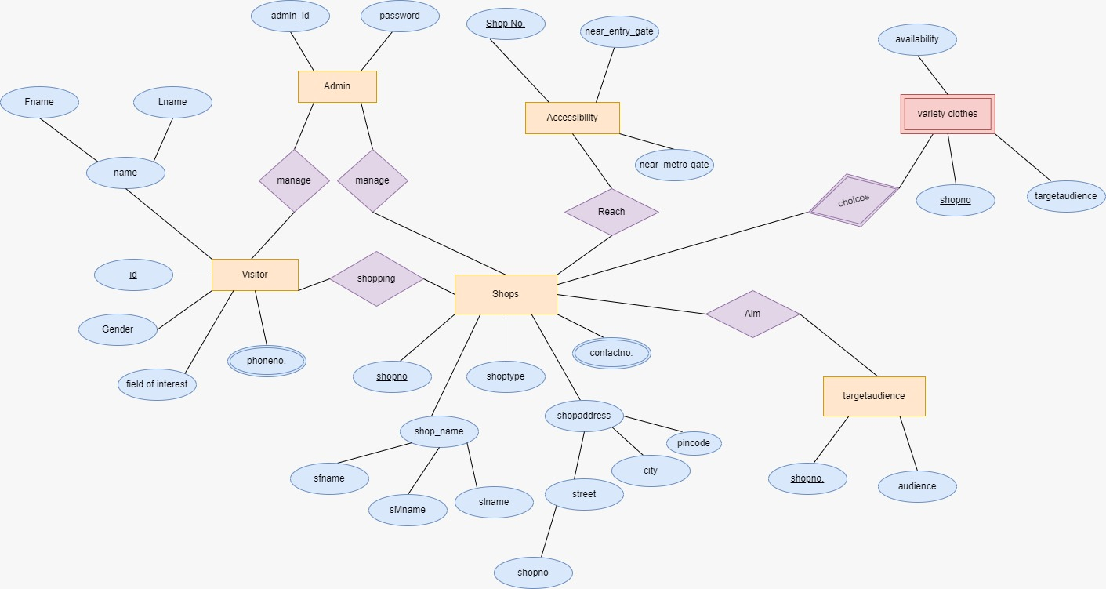

**ER DIAGRAM (UPDATED)**

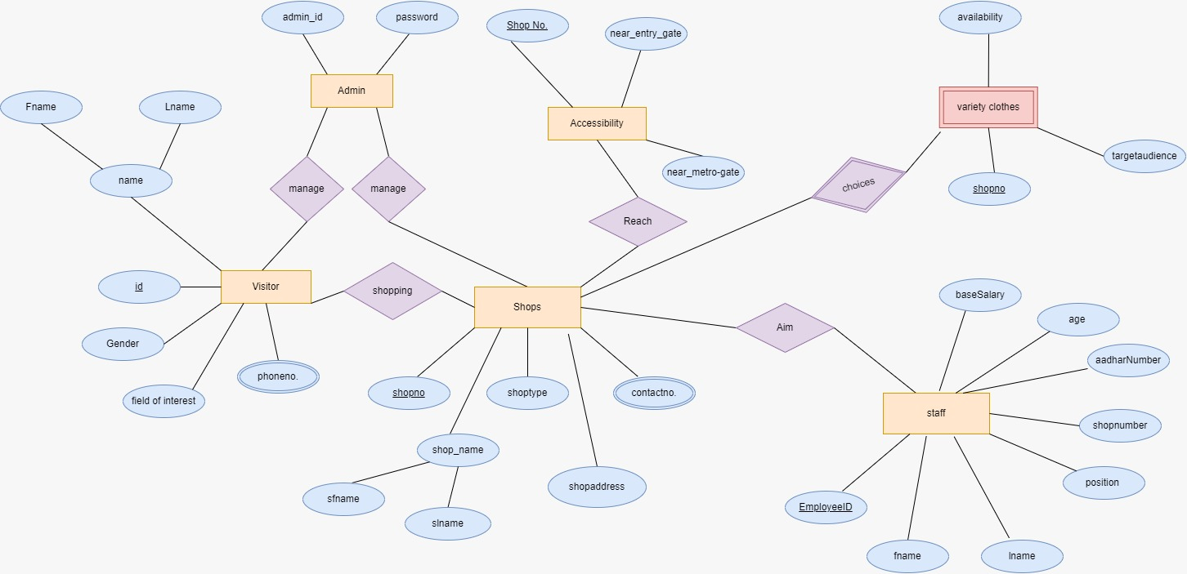

**MAPPING FROM ER MODEL TO R MODEL**

**VISITOR**

|  |  |  |  |  |  |
| --- | --- | --- | --- | --- | --- |
| **VISITOR ID** | **FNAME** | **LMANE** | **GENDER** | **MOBILE NO.** | **FIELD OF INTEREST** |

|  |  |  |  |  |  |  |
| --- | --- | --- | --- | --- | --- | --- |
| **SHOP NO** | **SFNAME** | **SMNAME** | **SLMANE** | **SHOPE_TYPE** | **SHOP_ADDRESS** | **CONTACT_NO.** |

**SHOPS**

**Accessibility**

|  |  |  |
| --- | --- | --- |
| **SHOP NO .** | **NEAR_ENTRY_GATE** | **NEAR_METRO_GATE** |

**VAREITY**

|  |  |  |  |
| --- | --- | --- | --- |
| **SHOP NO** | **STYLE** | **AVAILABILITY** | **TARGET_AUDIENCE** |

**STAFF**

|  |  |  |  |  |  |  |
| --- | --- | --- | --- | --- | --- | --- |
| **EMPLOYEE ID** | **FNAME** | **LNAME** | **POSITION** | **SHOP_NO** | **ADHAR_NO.** | **AGE** |

**Data gathering for project**

**Project Overview:**

Our project is focused on addressing real-life challenges, and to enhance its real-life application, we conducted data collection at Palika Bazar. Palika Bazar, being a government-regulated market, presented certain challenges in obtaining data from shopkeepers who were initially hesitant due to concerns about sharing information with unfamiliar entities. Despite these challenges, we persisted in our efforts to gather valuable data for the success of our project.

**Challenges Faced:**

The primary obstacle we encountered was the reluctance of shopkeepers to share detailed data about their shops. Understanding the sensitivities involved, we adjusted our approach, requesting at least essential information such as shop number, shop name, and the types of products they offered. This ensured that even if complete data was not obtained, we could still gather crucial information to contribute to the project's success.

**Engagement with Palika Bazar Administration:**

Recognizing the limitations in obtaining data directly from shopkeepers, we proactively engaged with the administration of Palika Bazar. However, we discovered that the administration itself lacked a comprehensive database of the shops operating within the market. This revelation led us to devise a strategic solution – creating a database ourselves and submitting it to the administration.

**Data Collected and Database Creation:**

We meticulously collected data for 130 shops, including shop numbers, shop names, types of shops, and their proximity to nearby gates and metro gates. To streamline this information, we organized it into a structured SQL database. While our initial efforts resulted in obtaining data for 100 shops, the completeness and accuracy of this dataset laid a solid foundation for the project.

**Future Steps:**

Moving forward, we aim to expand our database to encompass all 130 shops within Palika Bazar. This comprehensive dataset will not only serve the immediate needs of our project but will also contribute valuable insights to the administration for better market management.

In summary, our approach involved navigating the challenges of data collection in a government-regulated market, adapting our strategy to gather essential information, and proactively addressing the lack of an existing database by creating one ourselves. This comprehensive approach ensures the relevance and applicability of our project to real-world scenarios.

**Data Dictionary**

**Visitor**

|  |  |  |  |  |  |  |
| --- | --- | --- | --- | --- | --- | --- |
| **Column** | **Type** | **Null** | **Default** | **Links to** | **Comment** | **Media type** |
| Visitor_id | int | No |  |  |  |  |
| name | varchar(40) | No |  |  |  |  |
| gender | varchar(20) | No |  |  |  |  |
| Mobile_n0 | int | No |  |  |  |  |
| Field_of_interest | varchar(30) | No |  |  |  |  |

**SHOPS**

|  |  |  |  |  |  |  |
| --- | --- | --- | --- | --- | --- | --- |
| **Column** | **Type** | **Null** | **Default** | **Links to** | **Comment** | **Media type** |
| Shop_number | varchar(40) | No |  | Account |  |  |
| Shop_name | varchar(30) | No |  |  |  |  |
| Shop_type | varchar(10) | No |  |  |  |  |
| Shop_address | varchar(30) | No |  |  |  |  |
| Shop_contact_nu | varchar(40) | No |  |  |  |  |
| Shop_email | varchar(20) | No |  |  |  |  |

##### STAFF

|  |  |  |  |  |  |  |
| --- | --- | --- | --- | --- | --- | --- |
| **Column** | **Type** | **Null** | **Default** | **Links to** | **Comment** | **Media type** |
| employeeID | varchar(40) | No |  | account |  |  |
| Fname | varchar(30) | No |  | destination |  |  |
| Lname | varchar(20) | No |  | destination |  |  |
| Position | varchar(10) | No |  | destination |  |  |
| Shop number | Varchar(50) | No |  |  |  |  |
| Aadharnumber | varchar(10) | No |  |  |  |  |
| Age | varchar(10) | No |  |  |  |  |
| BaseSalary | Decimal(10,2) | No |  |  |  |  |

##### Variety

|  |  |  |  |  |  |  |
| --- | --- | --- | --- | --- | --- | --- |
| **Column** | **Type** | **Null** | **Default** | **Links to** | **Comment** | **Media type** |
| Shop_number | varchar(40) | No |  |  |  |  |
| Style | varchar(50) | No |  |  |  |  |
| Target_gender | varchar(20) | No |  |  |  |  |
| availibility | varchar(20) | No |  |  |  |  |

**BookPackage**

|  |  |  |  |  |  |  |
| --- | --- | --- | --- | --- | --- | --- |
| **Column** | **Type** | **Null** | **Default** | **Links to** | **Comment** | **Media type** |
| Shop_number | varchar(40) | No |  | Account |  |  |
| Near_enrty_gate | varchar(30) | No |  | Package |  |  |
| Near_metro_gate | varchar(20) | No |  |  |  |  |

## SQL QUERIES

##### BASIC SQL QUERIES FOR CREATING AND POPULATING DATA:

|  |  |  |  |
| --- | --- | --- | --- |
| **Query** | **Syntax** | **Function** | |
| CREATE | CREATE TABLE visitor (  visitor_id INT AUTO_INCREMENT PRIMARY KEY,  name VARCHAR(55) NOT NULL,  gender VARCHAR(10),  mobile_number VARCHAR(15),  field_of_interest VARCHAR(255)  ); | To create table account | |
| INSERT | INSERT INTO visitor (name, gender, mobile_number, field_of_interest) VALUES  ('himanshu joshi ', 'Male', '1234567890', 'Electronics'),  ('ishita', 'Female', '9876543210', 'Fashion and cloths'),  ('dhruv ', 'Male', '5551237777', 'Books'),  ('girika ', 'Female', '1112223333', 'Fashion and cloths'),  ('bhuvi', 'Female', '4445556666', 'Electronics'),  ('bhumika', 'Female', '7778889999', 'art and decoration'),  ('krish ', 'Male', '1239876543', 'Electronics'),  ('ria', 'Female', '5554443333', 'Fashion and cloths'),  ('ayush arya', 'Male', '9876543210', 'art and decoration'),  ('gracy', 'Female', '1112223333', 'Fashion'),  ('dhruv khasa', 'Male', '4445556666', 'Electronics'),  ('iima ', 'Female', '7778889999', 'Books'),  ('kunal', 'Male', '1239876543', 'Electronics '),  ('Ella Davis', 'Female', '5554443333', 'Fashion and cloths'),  ('James Brown', 'Male', '9876543210', 'Books'),  ('Emma Harris', 'Female', '1112223333', 'Fashion and cloths '),  ('Logan Miller', 'Male', '4445556666', 'art and decoration'),  ('Aria White', 'Female', '7778889999', 'Books and study material'),  ('Ethan Lee', 'Male', '1239876543', 'Electronics'); | | To dump values in account |

|  |  |  |
| --- | --- | --- |
| CREATE | CREATE TABLE shops (  shop_number int(10) PRIMARY KEY,  shop_name VARCHAR(50) ,  shop_type VARCHAR(50),  shop_address VARCHAR(100),  shop_contact_number int  ); | To create table shops |
| INSERT | (1, 'ULTRA TATTOOs ', 'tattoos and designing', 'shop no.1 palika bazar cp delhi', 9558889996),  (2, 'electronic palace ', 'electronic','shop no.2 palika bazar cp delhi', 9772221111),  (3, 'mahalaxami botique ', 'Clothing and fashion ', 'shop no.3 palika bazar cp delhi', 9449996666),  (4, 'fantasy store ', 'Clothing and fashion ', 'shop no.4 palika bazar cp delhi', 9223334444),  (5, 'rhythmis', 'Clothing and fashion', 'shop no.5 palika bazar cp delhi', 9998887777),  (6, 'new music balance', 'electronics','shop no.6 palika bazar cp delhi', 9334445555),  (7, 'alpha ', 'tattoos and desinging ', 'shop no.7 palika bazar cp delhi', 9776665555),  (8, 'shaw brother ', 'Clothing and fashion', 'shop no.8 palika bazar cp delhi', 9889990000),  (9, 'POINEER ', 'tattoos and designing', 'shop no.9 palika bazar cp delhi', 9112223333),  (10, 'shielma', 'Art and Decoration', 'shop no.10 palika bazar cp delhi', 9445556666),  (11, 'Gaming Galaxy', 'sports', 'shop no.11 palika bazar cp delhi', 9778889999),  (12, 'ISHAAN Paradise', 'Clothing and fashion', 'shop no.12 palika bazar cp delhi', 9887776666),  (13, 'JEWEL STORE', 'Jewellery', 'shop no.13 palika bazar cp delhi', 9556667777),  (14, 'STAR ELECTRONICS', 'Electronic', 'shop no.14 palika bazar cp delhi', 9998887777),  (15, 'Home Garden', 'Art and Decoration', 'shop no.15 palika bazar cp delhi', 9887776666),  (16, 'ZAMIN SHOOT STORE', 'Electronic', 'shop no.16 palika bazar cp delhi', 9332221111),  (17, 'ALBELA ART', 'tattoos and designing', 'shop no.17 palika bazar cp delhi', 9776665555),  (18, 'SHINE STAR', 'Electronics', 'shop no.18 palika bazar cp delhi', 9223334444),  (19, 'KAP', 'Books', 'shop no.19 palika bazar cp delhi', 9334445555),  (20, 'LAL BHARI TONDON', 'Clothing and fashion', 'shop no.20 palika bazar cp delhi', 9445556666),  (21, 'NAVNOOR CORNER', 'Clothing and fashion', 'shop no.21 palika bazar cp delhi', 9112223333),  (22, 'ROYAL PALCE', 'Electronics', 'shop no.22 palika bazar cp delhi', 9445556666),  (23, 'KHANNA department store', 'Clothing and fashion', 'shop no23. palika bazar cp delhi', 9778889999),  (24, 'KHALSA BUTT STORE', 'Art and Decoration', 'shop no.24 palika bazar cp delhi', 9887776666),  (25, 'AUDIO VIDEO CENTRE', 'Electronic', 'Shop no.25 palika bazar cp delhi', 9556667777),  (26, 'KING LAMP SHADE', 'Art and Decoration', 'Shop no.26 palika bazar cp delhi', 9998887777),  (27, 'SANCHITA', 'Clothing and fashion', 'Shop no.27 palika bazar cp delhi', 9332221111),  (28, 'ELCTRONIC AVENUE', 'Accessories and Perfums', 'Shop no.28 palika bazar cp delhi', 9776665555),  (29, 'LAXUMI GARMENTS', 'Clothing and fashion', 'Shop no.29 palika bazar cp delhi', 9223334444),  (30, 'RAJIV BOOK HOUSE', 'Clothing and fashion', 'Shop no.30 palika bazar cp delhi', 9334445555),  (31, 'ART PALACE', 'Art and Decoration', 'Shop no.31 palika bazar cp delhi', 9445556666),  (32, 'KING', 'Accessories and Perfums', 'Shop no.32 palika bazar cp delhi', 9887776666),  (33, 'GEM PALACE', 'Fashion', 'Shop no.33 palika bazar cp delhi', 9332221111),  (34, 'Elegant Ensemble', 'Fashion', 'Shop no.34 palika bazar cp delhi', 9776665555),  (35, 'THE PYRAMIDS', 'Clothing and fashion', 'Shop no.35 palika bazar cp delhi', 9223334444),  (36, 'RHYTHMS', 'Clothing and fashion', 'Shop no.36 palika bazar cp delhi', 9556667777),  (37, 'THE EXOTIC APPAREL', 'Electronics', 'Shop no.37 palika bazar cp delhi', 9998887777),  (38, 'NOT AVAILABLE', NULL, 'Shop no.38 palika bazar cp delhi', 3332221111),  (39, 'GOD BLESSING', 'Clothing and fashion', 'Shop no.39 palika bazar cp delhi', 7776665555),  (40, 'GENASH MINIMUM', 'Clothing and fashion', 'Shop no.40 palika bazar cp delhi', 8887776666),  (41, 'A ONE CREATIONS', 'Clothing and fashion', 'palika bazar cp delhi', 3332221111),  (42, 'MOHIT INTERVISON', 'Clothing and fashion', 'palika bazar cp delhi', 7776665555),  (43, 'FIX PRICE STORE', 'Clothing and fashion', 'palika bazar cp delhi', 2223334444),  (44, 'D. K. FASHION', 'Clothing and fashion', 'palika bazar cp delhi', 7778889999),  (45, 'SARGAM FASHION', 'Clothing and fashion', 'palika bazar cp delhi', 8887776666),  (46, 'TRUE COLOURS', 'Electronics', 'palika bazar cp delhi', 5556667777),  (47, 'SARGUM FASHIONS', 'Clothing and fashion', 'palika bazar cp delhi', 9998887777),  (48, 'MUSKESH FASHION', 'Clothing and fashion', 'palika bazar cp delhi', 3332221111),  (49, 'SMT PRIYA CHAUDHARY', 'Clothing and fashion', 'palika bazar cp delhi', 7776665555),  (50, 'S. K. ENTERPRISE', 'Clothing and fashion', 'palika bazar cp delhi', 8887776666),  (51, 'RAICHALA COLLECTION', 'Clothing and fashion', 'palika bazar cp delhi', 3332221111),  (52, 'AANCHAL FASHION', 'Clothing and fashion', 'palika bazar cp delhi', 7776665555),  (53, NULL, NULL, 'palika bazar cp delhi', 2223334444),  (54, 'FIFTY FOUR', 'Clothing and fashion', '7palika bazar cp delhi', 7778889999),  (55, 'GULATI STORE', 'Clothing and fashion', 'palika bazar cp delhi', 8887776666),  (56, 'TREHAN STORE', 'Clothing and fashion', 'palika bazar cp delhi', 5556667777),  (57, 'IDEAL SALE', 'Clothing and fashion', 'palika bazar cp delhi', 3332221111),  (58, NULL, NULL, 'palika bazar cp delhi', 7776665555),  (59, 'M S FOOTWEAR', 'Footwears', 'palika bazar cp delhi', 2223334444),  (60, 'SILVER MOON', 'Jewelry', 'palika bazar cp delhi', 7778889999),  (61, 'MAHARAJSON SAREEE STORE', 'Clothing and fashion', 'palika bazar cp delhi', 8887776666),  (62, 'JEANS STORE', 'Clothing and fashion', 'palika bazar cp delhi', 5556667777),  (63, 'KAMAL SAREES', 'Footwears', 'palika bazar cp delhi', 3332221111),  (64, NULL, NULL, 'palika bazar cp delhi', 7776665555),  (65, 'M.A.AZIZ', 'Clothing and fashion', 'palika bazar cp delhi', 8887776666),  (66, 'KARDIRSONS', 'Electronics', 'shop no.66 palika bazar cp delhi', 9334445555),  (67, 'YOGGEETA GARMENTS', 'Tattoos and Designing', 'shop no.67 palika bazar cp delhi', 9776665555),  (68, NULL, NULL, 'shop no.68 palika bazar cp delhi', 9889990000),  (69, 'STUFF', 'tattoos and designing', 'shop no.69 palika bazar cp delhi', 9112223333),  (70, 'GARDEN SHOP', 'Footwears', 'shop no.60 palika bazar cp delhi', 9445556666),  (71, 'DINESH MILLS RETAILS STORE', 'Sports', 'shop no.71 palika bazar cp delhi', 9778889999),  (72, 'WOMENS ERA', 'Clothing and fashion', 'shop no.72 palika bazar cp delhi', 9887776666),  (73, 'MS BHAGAT', 'Clothing and fashion', 'shop no.73 palika bazar cp delhi', 9556667777),  (74, NULL, NULL, 'shop no.74 palika bazar cp delhi', 9998887777),  (75, 'BHARAT TEXTILE', 'Clothing and fashion', 'shop no.75 palika bazar cp delhi', 9887776666),  (76, 'JOGINDER LAL KHANNA & CO.', 'Clothing and fashion', 'shop no.76 palika bazar cp delhi', 9332221111),  (77, 'SEVENTY SEVEN', 'Clothing and fashion', 'shop no.77 palika bazar cp delhi', 9776665555),  (78, 'CURES', 'Electronics', 'shop no.78 palika bazar cp delhi', 9223334444),  (79, NULL, NULL, 'shop no.79 palika bazar cp delhi', 9334445555),  (80, 'RAZ SONS', 'Clothing and fashion', 'shop no.80 palika bazar cp delhi', 9445556666),  (81, 'NOOR CORNER', 'Clothing and fashion', 'palika bazar cp delhi', 9112223333),  (82, 'RAHUL ENTERPRISES', 'Electronics', 'palika bazar cp delhi', 9445556666),  (83, 'VINOD GARMENTS', 'Clothing and fashion', 'palika bazar cp delhi', 9778889999),  (84, NULL, NULL, 'palika bazar cp delhi', 9887776666),  (85, 'ESSENTIAL GARMENTS', 'Electronic', 'palika bazar cp delhi', 9556667777),  (86, 'LADY CORNER', 'Clothing and fashion', 'palika bazar cp delhi', 9998887777),  (87, 'TOP SHOP', 'Clothing and fashion', 'palika bazar cp delhi', 9332221111),  (88, 'THE ADAM N EVE', 'Accessories and Perfums', 'palika bazar cp delhi', 9776665555),  (89, 'TANU EMPORIUM', 'Clothing and fashion', 'palika bazar cp delhi', 9223334444),  (90, 'RAZ SELECTION', 'Clothing and fashion', 'palika bazar cp delhi', 9334445555); | To dump values in shops |
|  |  |  |
|  |  |  |
|  |  |  |
|  |  |  |
|  |  |  |
|  |  |  |

|  |  |  |
| --- | --- | --- |
| CREATE | CREATE TABLE staff (  EmployeeID VARCHAR(3) PRIMARY KEY,  FirstName VARCHAR(50),  LastName VARCHAR(50),  Position VARCHAR(50),  ShopNumber INT,  AadharNumber VARCHAR(15),  Age INT,  BaseSalary DECIMAL(10, 2)  ); | To create table hotel |
| CREATE | INSERT INTO staff (EmployeeID, FirstName, LastName, Position, ShopNumber, AadharNumber, Age, BaseSalary)  VALUES  ('001', 'Aarav', 'Sharma', 'Sales Associate', 1, '1234-5678-9012', 25, 23000.00),  ('002', 'Aditi', 'Patel', 'Cashier', 2, '2345-6789-0123', 28, 13000.00),  ('003', 'Akash', 'Singh', 'Store Manager', 1, '3456-7890-1234', 32, 15000.00),  ('004', 'Anaya', 'Kapoor', 'Sales Associate', 3, '4567-8901-2345', 26, 23000.00),  ('005', 'Arjun', 'Verma', 'Stock Clerk', 2, '5678-9012-3456', 30, 22000.00),  ('006', 'Aryan', 'Shah', 'Store Manager', 3, '6789-0123-4567', 35, 20000.00),  ('007', 'Chhaya', 'Bansal', 'Cashier', 4, '7890-1234-5678', 22, 15000.00),  ('008', 'Darsh', 'Rao', 'Sales Associate', 5, '8901-2345-6789', 29, 25000.00),  ('009', 'Dia', 'Gupta', 'Stock Clerk', 6, '9012-3456-7890', 27, 23000.00),  ('010', 'Divya', 'Yadav', 'Cashier', 4, '0123-4567-8901', 31, 35000.00),  ('011', 'Esha', 'Shukla', 'Store Manager', 5, '9876-5432-1098', 34, 19000.00),  ('012', 'Harsh', 'Malhotra', 'Stock Clerk', 5, '8765-4321-0987', 25, 16000.00),  ('013', 'Ishaan', 'Agrawal', 'Sales Associate', 6, '7654-3210-9876', 28, 30000.00),  ('014', 'Jai', 'Deshmukh', 'Store Manager', 7, '6543-2109-8765', 33, 5000.00),  ('015', 'Kabir', 'Nair', 'Cashier', 7, '5432-1098-7654', 29, 35000.00),  ('016', 'Kavya', 'Reddy', 'Stock Clerk', 8, '4321-0987-6543', 26, 32000.00),  ('017', 'Laksh', 'Gandhi', 'Sales Associate', 9, '3210-9876-5432', 31, 7000.00),  ('018', 'Mahi', 'Kulkarni', 'Store Manager', 10, '2109-8765-4321', 27, 14000.00),  ('019', 'Manya', 'Nanda', 'Cashier', 11, '1098-7654-3210', 32, 35000.00),  ('020', 'Maya', 'Joshi', 'Stock Clerk', 12, '0987-6543-2109', 24, 32000.00),  ('021', 'Nakul', 'Saxena', 'Sales Associate', 13, '9876-5432-1098', 30, 30000.00),  ('022', 'Nia', 'Chopra', 'Store Manager', 14, '8765-4321-0987', 35, 50000.00),  ('023', 'Om', 'Khanna', 'Cashier', 15, '7654-3210-9876', 28, 35000.00),  ('024', 'Prisha', 'Rajput', 'Stock Clerk', 16, '6543-2109-8765', 26, 32000.00),  ('025', 'Rahul', 'Bhat', 'Sales Associate', 16, '5432-1098-7654', 29, 30000.00),  ('026', 'Rhea', 'Choudhary', 'Store Manager', 21, '4321-0987-6543', 33, 50000.00),  ('027', 'Rudra', 'Shukla', 'Cashier', 17, '3210-9876-5432', 31, 35000.00),  ('028', 'Saumya', 'Pandey', 'Stock Clerk', 18, '2109-8765-4321', 28, 32000.00),  ('029', 'Shanaya', 'Rawat', 'Sales Associate', 19, '1098-7654-3210', 30, 30000.00),  ('030', 'Shaurya', 'Goswami', 'Store Manager', 20, '0987-6543-2109', 34, 50000.00),  ('031', 'Siya', 'Dixit', 'Cashier', 21, '9876-5432-1098', 26, 35000.00),  ('032', 'Tanish', 'Gupta', 'Stock Clerk', 22, '8765-4321-0987', 29, 12000.00),  ('033', 'Tara', 'Sharma', 'Sales Associate', 23, '7654-3210-9876', 31, 30000.00),  ('034', 'Uday', 'Patil', 'Store Manager', 24, '6543-2109-8765', 33, 50000.00),  ('035', 'Vanya', 'Sinha', 'Cashier', 25, '5432-1098-7654', 27, 35000.00),  ('036', 'Vihaan', 'Chauhan', 'Stock Clerk', 26, '4321-0987-6543', 32, 32000.00),  ('037', 'Yash', 'Kumar', 'Sales Associate', 27, '3210-9876-5432', 25, 20000.00),  ('038', 'Zara', 'Gandhi', 'Store Manager', 28, '2109-8765-4321', 28, 50000.00),  ('039', 'Zayn', 'Yadav', 'Cashier', 29, '1098-7654-3210', 30, 35000.00),  ('040', 'Aanya', 'Sharma', 'Stock Clerk', 30, '0987-6543-2109', 34, 32000.00),  ('041', 'Aarush', 'Shah', 'Sales Associate', 31, '9876-5432-1098', 31, 30000.00),  ('042', 'Aisha', 'Rao', 'Store Manager', 32, '8765-4321-0987', 29, 5000.00),  ('043', 'Arnav', 'Verma', 'Cashier', 33, '7654-3210-9876', 26, 35000.00),  ('044', 'Avni', 'Chopra', 'Stock Clerk', 34, '6543-2109-8765', 28, 32000.00),  ('045', 'Dev', 'Saxena', 'Sales Associate', 35, '5432-1098-7654', 33, 30000.00),  ('046', 'Ishita', 'Nair', 'Store Manager', 35, '4321-0987-6543', 32, 50000.00),  ('047', 'Karan', 'Gupta', 'Cashier', 36, '3210-9876-5432', 27, 9000.00),  ('048', 'Kiara', 'Malhotra', 'Stock Clerk', 37, '2109-8765-4321', 29, 32000.00),  ('049', 'Manav', 'Bhat', 'Sales Associate', 38, '1098-7654-3210', 28, 30000.00),  ('050', 'Myra', 'Choudhary', 'Store Manager', 39, '0987-6543-2109', 30, 50000.00),  ('051', 'Aanya', 'Rai', 'Cashier', 40, '9876-5432-1098', 26, 35000.00),  ('052', 'Aarush', 'Sharma', 'Stock Clerk', 41, '8765-4321-0987', 29, 32000.00),  ('053', 'Aisha', 'Dixit', 'Sales Associate', 43, '7654-3210-9876', 31, 30000.00),  ('054', 'Arnav', 'Patil', 'Store Manager', 42, '6543-2109-8765', 33, 50000.00),  ('055', 'Avni', 'Rawat', 'Cashier', 43, '5432-1098-7654', 27, 15000.00),  ('056', 'Dev', 'Nanda', 'Stock Clerk', 44, '4321-0987-6543', 32, 32000.00),  ('057', 'Ishita', 'Sinha', 'Sales Associate', 45, '3210-9876-5432', 25, 30000.00),  ('058', 'Karan', 'Kulkarni', 'Store Manager', 46, '2109-8765-4321', 28, 50000.00),  ('059', 'Kiara', 'Goswami', 'Cashier', 47, '1098-7654-3210', 30, 35000.00),  ('060', 'Manav', 'Shah', 'Stock Clerk', 48, '0987-6543-2109', 34, 32000.00),  ('061', 'Myra', 'Malhotra', 'Sales Associate', 49, '9876-5432-1098', 31, 30000.00),  ('062', 'Nakul', 'Rao', 'Store Manager', 50, '8765-4321-0987', 29, 6000.00),  ('063', 'Nia', 'Sharma', 'Cashier', 51, '7654-3210-9876', 26, 8000.00),  ('064', 'Om', 'Verma', 'Stock Clerk', 52, '6543-2109-8765', 28, 32000.00),  ('065', 'Prisha', 'Chopra', 'Sales Associate', 53, '5432-1098-7654', 33, 13000.00),  ('066', 'Rahul', 'Khanna', 'Store Manager', 54, '4321-0987-6543', 32, 50000.00),  ('067', 'Rhea', 'Rajput', 'Cashier', 55, '3210-9876-5432', 27, 35000.00),  ('068', 'Rudra', 'Bhat', 'Stock Clerk', 54, '2109-8765-4321', 29, 32000.00),  ('069', 'Saumya', 'Choudhary', 'Sales Associate', 56, '1098-7654-3210', 28, 30000.00),  ('070', 'Shanaya', 'Saxena', 'Store Manager', 57, '0987-6543-2109', 30, 50000.00); | To create table bookHotel |

|  |  |  |
| --- | --- | --- |
|  | su varchar(20) NOT NULL); |  |
| CREATE | CREATE TABLE variety (  shop_number INT,  style VARCHAR(255),  target_gender VARCHAR(10),  availability VARCHAR(255)  ); | To create table bookPackage |
| INSERT | INSERT INTO variety (shop_number, style, target_gender, availability) VALUES  (1, 'tattoos ', 'unisex', 'available'),  (2, 'mobiles and tech ', 'male', 'In Stock'),  (3, 'western style ', 'male', 'Limited Stock'),  (4, 'Tech Gadgets', 'me', 'In Stock'),  (5, 'Athletic Wear', 'Unisex', 'Limited Stock'),  (6, 'camera and gargets', 'Unisex', 'In Stock'),  (7, 'tattoos', 'Unisex', 'In Stock'),  (8, 'traditional clothing', 'female', 'In Stock'),  (9, 'tattoos', 'Unisex', 'available'),  (10, 'western style', 'male', 'In Stock'),  (11, 'Gaming Merchandise', 'Unisex', 'In Stock'),  (12, 'western style', 'male', 'In Stock'),  (13, 'jewellery', 'female', 'Limited Stock'),  (14, 'tech gadgets ', 'Unisex', 'In Stock'),  (15, 'mobiles and tech ', 'Unisex', 'In Stock'),  (16, '', 'Unisex', 'Limited Stock'),  (17, 'Tech Accessories', 'Unisex', 'In Stock'),  (18, 'Literary Attire', 'Unisex', 'In Stock'),  (19, 'Fashion Accessories', 'Unisex', 'Limited Stock'),  (20, 'Garden Fashion', 'Unisex', 'In Stock'),  (21, 'western style ', 'male', 'Limited Stock'),  (22, 'electronics', 'Unisex', 'In Stock'),  (23, 'formals ', 'male', 'In Stock'),  (24, 'lights ', 'Unisex', 'Limited Stock'),  (25, 'mobiles and tech', 'Unisex', 'In Stock'),  (26, ' lighting decoration ', 'Unisex', 'In Stock'),  (27, 'western style ', 'mele', 'Limited Stock'),  (28, 'fashion accessories ', 'female', 'In Stock'),  (29, 'western casual style ', 'male', 'In Stock'),  (30, 'western casual style ', 'male', 'Limited Stock'),  (31, 'artistic decoration ', 'Unisex', 'In Stock'),  (32, 'watch and tech ', 'Unisex', 'In Stock'),  (33, 'watch and tech', 'Unisex', 'Limited Stock'),  (34, 'null', 'Unisex', 'In Stock'),  (35, 'western casual style', 'Unisex', 'In Stock'),  (36, 'western casual style ', 'male ', 'In Stock'),  (37, 'western casual style ', 'Unisex', 'Limited Stock'),  (38, 'null ', 'Unisex', 'In Stock'),  (39, 'western casual style', 'male ', 'In Stock'),  (40, 'western casual style', 'male', 'Limited Stock'),  (41, 'western casual style', 'Unisex', 'In Stock'),  (42, 'winter fits ', 'Unisex', 'In Stock'),  (43, 'western casual style', 'male ', 'Limited Stock'),  (44, 'western casual style', 'male', 'In Stock'),  (45, 'western casual style', 'male', 'In Stock'),  (46, 'western casual style', 'male', 'In Stock'),  (47, 'western casual style', 'male ', 'Limited Stock'),  (48, 'western casual style', 'male', 'In Stock'),  (49, 'western casual style', 'male', 'In Stock'),  (50, 'western casual style', 'male', 'Limited Stock'),  (51, 'western casual style', 'male', 'In Stock'),  (52, 'kids clothing', 'Unisex', 'In Stock'),  (53, 'null', 'Unisex', 'Limited Stock'),  (54, 'western casual style', 'male', 'In Stock'),  (55, 'western casual style', 'male', 'In Stock'),  (56, 'western casual style', 'Unisex', 'Limited Stock'),  (57, 'western casual style', 'male', 'In Stock'),  (58, 'null', 'Unisex', 'In Stock'),  (59, 'footwears', 'Unisex', 'Limited Stock'),  (60, 'jewellery ', 'fashion ', 'In Stock'),  (61, 'traditional clothings ', 'female', 'Limited Stock'),  (62, 'western casual style', 'Unisex', 'In Stock'),  (63, 'foootwears ', 'Unisex', 'In Stock'),  (64, 'null ', 'Unisex', 'Limited Stock'),  (65, 'traditional clothing ', 'female', 'In Stock'),  (67, 'traditional clothing ', 'female', 'In Stock'),  (67, 'western casual style ', 'female', 'In Stock'),  (68, 'null ', 'unisex', 'In Stock'),  (69, ' western casual style ', 'unisex', 'In Stock'),  (70, 'footwears', 'unisex', 'In Stock'),  (71, 'western casual style', 'female', 'In Stock'),  (72, 'bra and undergarments', 'female', 'In Stock'),  (73, 'western casual style', 'female', 'In Stock'),  (74, 'null', 'male', 'In Stock'),  (75, 'western casual style', 'female', 'In Stock'),  (76, 'western casual style', 'female', 'In Stock'),  (77, 'kids clothing ', 'unisex', 'In Stock'),  (78, 'western casual style', 'female', 'In Stock'),  (79, 'null', 'female', 'In Stock'),  (80, 'western casual style', 'female', 'In Stock'),  (81, 'western casual style', 'male', 'In Stock'),  (82, 'mobiles and tech', 'unisex', 'In Stock'),  (83, 'western casual style', 'male', 'In Stock'),  (84, 'null', 'male', 'In Stock'),  (85, 'kids clothing ', 'unisex ', 'In Stock'),  (86, 'western casual style', 'female', 'In Stock'),  (87, 'western casual style', 'female', 'In Stock'),  (88, 'western casual style', 'male', 'In Stock'),  (89, 'winter fits ', 'male', 'In Stock'),  (90, 'western casual style', 'male', 'In Stock'); | To populate package table |

|  |  |  |
| --- | --- | --- |
| CREATE | CREATE TABLE accessibility (  shop_number INT,  near_entry_gate VARCHAR(255),  near_metro_gate VARCHAR(255)  ); | To create table destination |

|  |  |  |
| --- | --- | --- |
| INSERT | INSERT INTO accessibility (shop_number, near_entry_gate, near_metro_gate) VALUES  (1, 'Gate 1 ', ' gate 5 Rajiv Chowk metro station '),  (2, 'Gate 1', 'gate 5 Rajiv Chowk'),  (3, 'Gate 1', 'gate 5 Rajiv Chowk'),  (4, 'Gate 1', 'gate 5 Rajiv Chowk'),  (5, 'Gate 1', 'gate 5 Rajiv Chowk'),  (6, 'Gate 1', 'gate 5 Rajiv Chowk'),  (7, 'Gate 1', 'gate 5 Rajiv Chowk'),  (8, 'Gate 1', 'gate 5 Rajiv Chowk'),  (9, 'Gate 1', 'gate 5 Rajiv Chowk'),  (10, 'Gate 5', 'gate 5 Rajiv Chowk'),  (11, 'Gate 5', 'gate 5 Rajiv Chowk'),  (12, 'Gate 5', 'gate 5 Rajiv Chowk'),  (13, 'Gate 5', 'gate 6 Rajiv Chowk'),  (14, 'Gate 5', 'gate 6 Rajiv Chowk'),  (15, 'Gate 5', 'gate 6 Rajiv Chowk '),  (16, 'Gate 5', 'gate 6 Rajiv Chowk'),  (17, 'Gate 5', 'gate 6 Rajiv Chowk'),  (18, 'Gate 5', 'gate 6 Rajiv Chowk'),  (19, 'Gate 4', 'gate 2 Rajiv Chowk'),  (20, 'Gate 4', 'gate 2 Rajiv Chowk'),  (21, 'Gate 4 ', 'gate 2 gate 6Rajiv Chowk metro station '),  (22, 'Gate 4', 'gate 2 Rajiv Chowk'),  (23, 'Gate 4', 'gate 2 Rajiv Chowk'),  (24, 'Gate 4', 'gate 2 Rajiv Chowk'),  (25, 'Gate 4', 'gate 2 Rajiv Chowk'),  (26, 'Gate 4', ' gate 2 Rajiv Chowk'),  (27, 'Gate 1', ' gate 5 Rajiv Chowk'),  (28, 'Gate 1', 'gate 5 Rajiv Chowk'),  (29, 'Gate 1', 'gate 5 Rajiv Chowk'),  (30, 'Gate 1', 'gate 5 Rajiv Chowk'),  (31, 'Gate 1', 'gate 5 Rajiv Chowk'),  (32, 'Gate 1', 'gate 5 Rajiv Chowk'),  (33, 'Gate 1', 'gate 5 Rajiv Chowk'),  (34, 'Gate 1', 'gate 5 Rajiv Chowk'),  (35, 'Gate 1', 'gate 5 Rajiv Chowk '),  (36, 'Gate 1', 'gate 5 Rajiv Chowk'),  (37, 'Gate 1', 'gate 5 Rajiv Chowk'),  (38, 'Gate 1', 'gate 5 Rajiv Chowk'),  (39, 'Gate 1', 'gate 5 Rajiv Chowk'),  (40, 'Gate 1', 'gate 5 Rajiv Chowk'),  (41, 'Gate 1', 'gate 5 Rajiv Chowk'),  (42, 'Gate 3', 'Rajiv Chowk'),  (43, 'Gate 3', 'gate 2 Rajiv Chowk'),  (44, 'Gate 3', 'gate 2 Rajiv Chowk'),  (45, 'Gate 3', 'gate 2 Rajiv Chowk'),  (46, 'Gate 3', 'gate 2 Rajiv Chowk'),  (47, 'Gate 3', 'gate 2 Rajiv Chowk'),  (48, 'Gate 3', 'gate 2 Rajiv Chowk'),  (49, 'Gate 3', 'gate 2 Rajiv Chowk'),  (50, 'Gate 3', 'gate 2 Rajiv Chowk'),  (51, 'Gate 3 ', ' gate 6 Rajiv Chowk metro station '),  (52, 'Gate 1', 'gate 6 Rajiv Chowk'),  (53, 'Gate 3', 'gate 6 Rajiv Chowk'),  (54, 'Gate 4', 'gate 6 Rajiv Chowk'),  (55, 'Gate 4', 'gate 6 Rajiv Chowk'),  (56, 'Gate 4', 'gate 6 Rajiv Chowk'),  (57, 'Gate 4', 'gate 6 Rajiv Chowk'),  (58, 'Gate 4', 'gate 6 Rajiv Chowk'),  (59, 'Gate 4', 'gate 6 Rajiv Chowk'),  (60, 'Gate 4', 'Rajiv Chowk'),  (61, 'Gate 5', 'Rajiv Chowk'),  (62, 'Gate 5', 'Rajiv Chowk'),  (63, 'Gate 5', 'Rajiv Chowk'),  (64, 'Gate 5', 'Rajiv Chowk'),  (65, 'Gate 5', 'Rajiv Chowk '),  (66, 'Gate 5', 'Rajiv Chowk'),  (67, 'Gate 5', 'Rajiv Chowk'),  (68, 'Gate 5', 'Rajiv Chowk'),  (69, 'Gate 6', 'Rajiv Chowk'),  (70, 'Gate 6', 'Rajiv Chowk'),  (71, 'Gate 6 ', ' gate 1 Rajiv Chowk metro station '),  (72, 'Gate 6', ' gate 1 Rajiv Chowk'),  (73, 'Gate 6', ' gate 1 Rajiv Chowk'),  (74, 'Gate 6', ' gate 1 Rajiv Chowk'),  (75, 'Gate 6', ' gate 1 Rajiv Chowk'),  (76, 'Gate 6', ' gate 1 Rajiv Chowk'),  (77, 'Gate 1', 'Rajiv Chowk'),  (78, 'Gate 1', 'Rajiv Chowk'),  (79, 'Gate 1', 'Rajiv Chowk'),  (80, 'Gate 1', 'Rajiv Chowk'),  (81, 'Gate 1', 'Rajiv Chowk'),  (82, 'Gate 1', 'Rajiv Chowk'),  (83, 'Gate 1', 'Rajiv Chowk'),  (84, 'Gate 1', 'Rajiv Chowk'),  (85, 'Gate 1', 'Rajiv Chowk '),  (86, 'Gate 1', 'Rajiv Chowk'),  (87, 'Gate 1', 'Rajiv Chowk'),  (88, 'Gate 1', 'Rajiv Chowk'),  (89, 'Gate 1', 'Rajiv Chowk'),  (90, 'Gate 1', 'Rajiv Chowk'),  (91, 'Gate 1 ', 'gate 6 Rajiv Chowk metro station '),  (92, 'Gate 6', 'Rajiv Chowk'),  (93, 'Gate 6', 'Rajiv Chowk'),  (94, 'Gate 6', 'Rajiv Chowk'),  (95, 'Gate 6', 'Rajiv Chowk'),  (96, 'Gate 6', 'Rajiv Chowk'),  (97, 'Gate 6', 'Rajiv Chowk'),  (98, 'Gate 6', 'Rajiv Chowk'),  (99, 'Gate 6', 'Rajiv Chowk'),  (100, 'Gate 6', 'Rajiv Chowk'); |  |

**BASIC OPERATION**

1 Retrieve information on all the shops who provide services for women only.

SELECT s.*, v.target_gender

FROM shops s

JOIN variety v ON s.shop_number = v.shop_number WHERE v.target_gender='female';

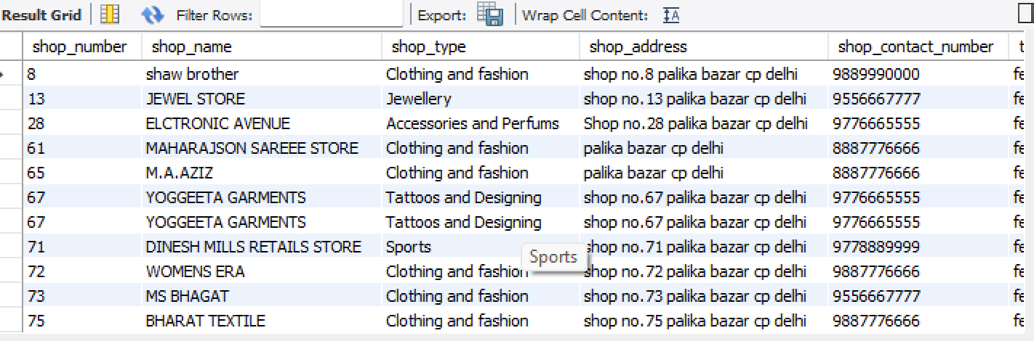

2 - Retrieve information on all the shops which have traditional cloths in there shop

SELECT s.*, v.style, v.target_gender, v.availability

FROM shops s

JOIN variety v ON s.shop_number = v.shop_number

WHERE v.style = 'bra and undergarments;

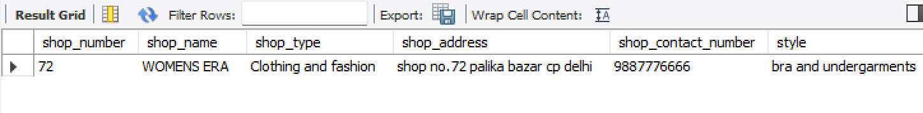

3- Retrieve information on all the shops which have footwear in the.

SELECT *

FROM shops

WHERE shop_type = 'tattoos and desings ';

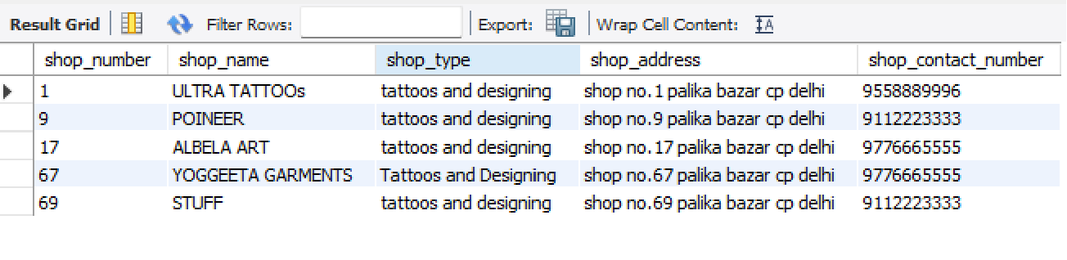

4 - - give information of all the shops which are near gate 1.

SELECT shop_number , shop_name , shop_type

FROM shops

WHERE shop_number in (SELECT shop_number FROM accessibility WHERE near_entry_gate = 'Gate 1');

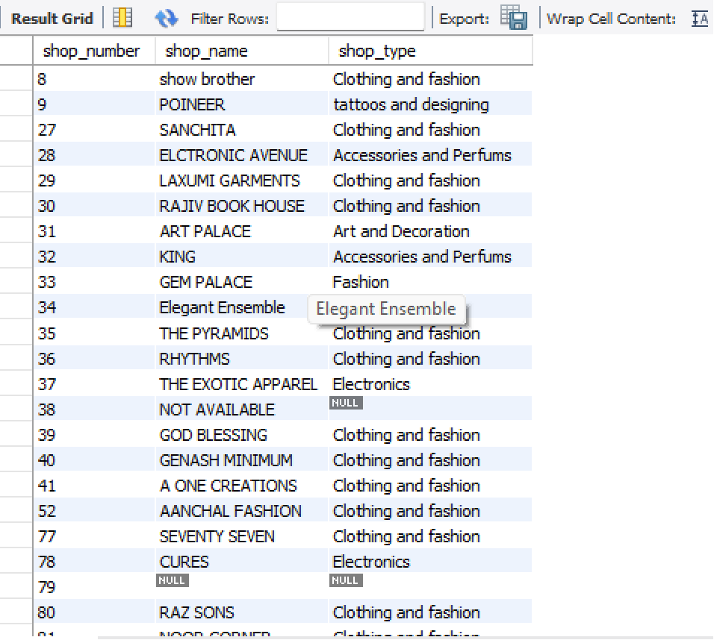

5 - find the employee in staff how have base salary less 10000.

select *

from staff

where BaseSalary < 10000;

6 - find the near entry gate and near metro gate which are near shop number = ‘77’

SELECT shop_number ,near_entry_gate , near_metro_gate

FROM accessibility

WHERE shop_number = 77;

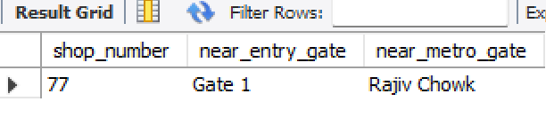

7 – find the information of staff member of shop no = 4

select *

from staff

where ShopNumber = 4 ;

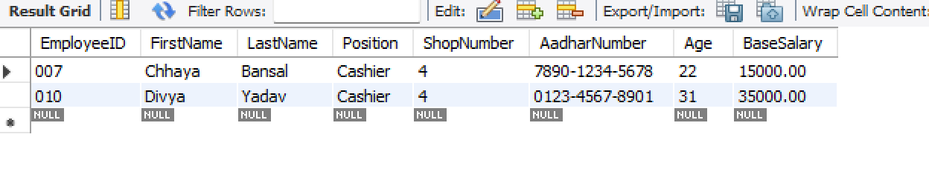

8 - Retrieve information on all the shops which have footwear in the.

SELECT *

FROM shops

WHERE shop_type = 'art and decoration ';

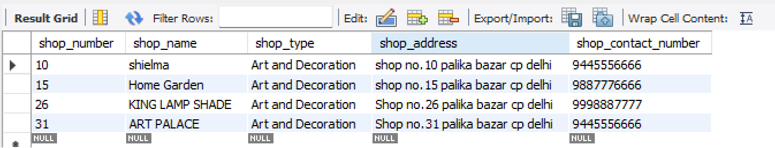

9 - **List employees with their positions and ages in the range of 25 to 30:**

sql

SELECT EmployeeID, FirstName, LastName, Position, Age

FROM staff

WHERE Age BETWEEN 25 AND 30;

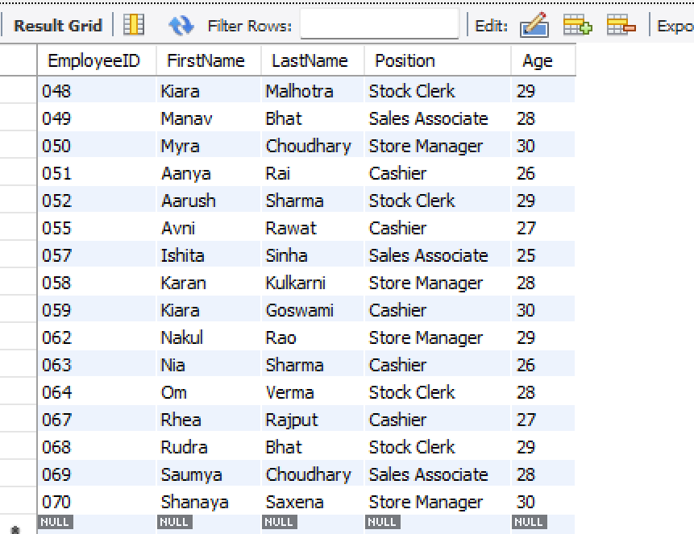

Retrieve the employees how gets second highest salary

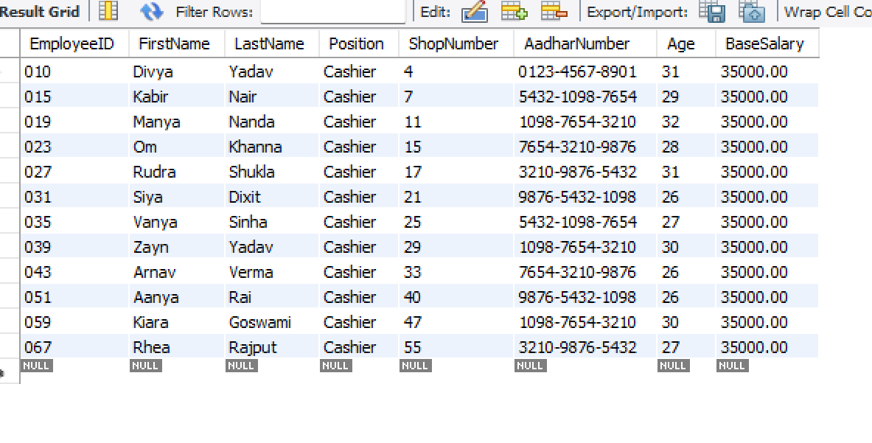

Q - This query retrieves information about visitors who have shown interest in various fields

and the corresponding shops they are interested in.

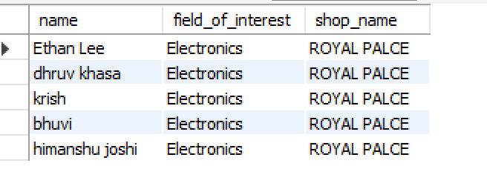

Q Retrieve the staff who have more salry than average .

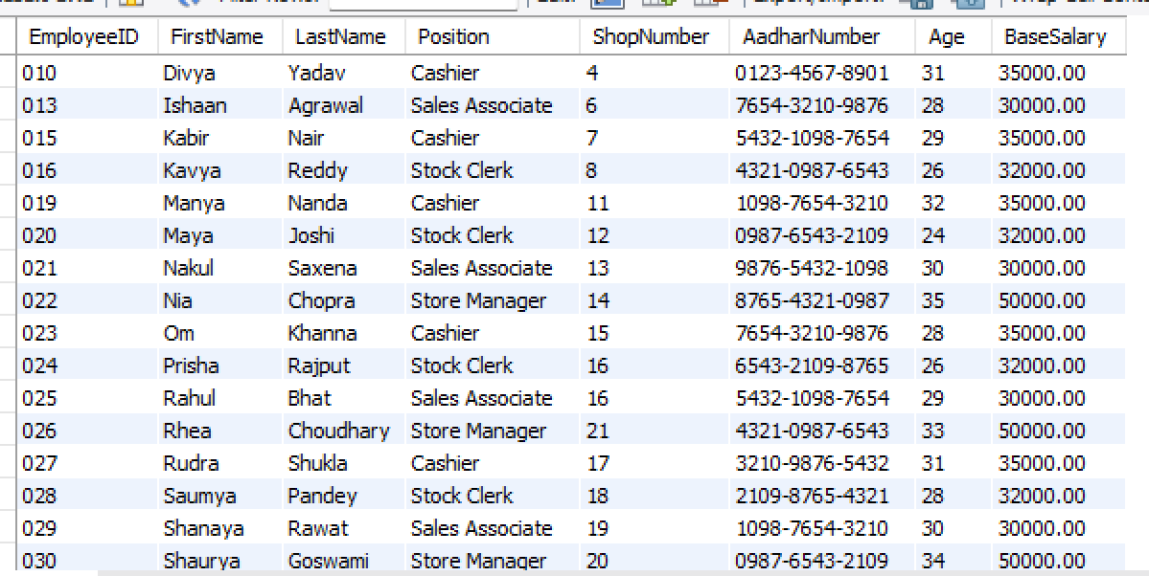

Q

Oreder by staff according to your basesalary

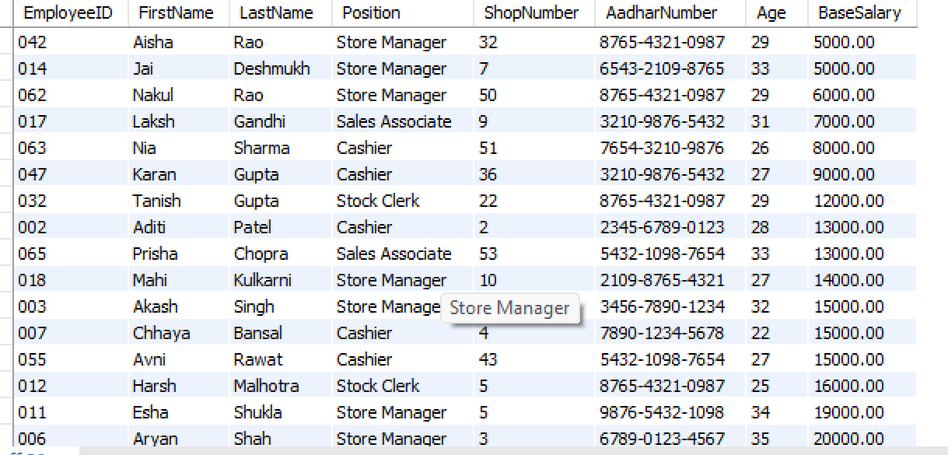

Q finding the shops which have employee count more than one.

( acc to data only shop no 5 have )

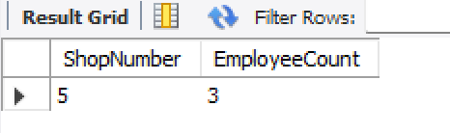

Question - Average age of employee by position . find out the avg age of employee according to there position.

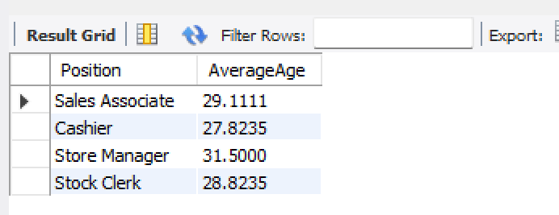

10 - This query retrieves information about visitors who have shown interest in various fields

and the corresponding shops they are interested in

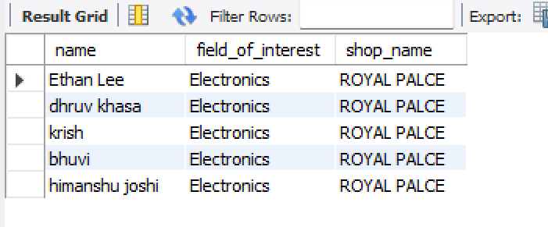

11 retrieves the names of shops that have at least one visitor interested in the 'western casual style ' field of interest

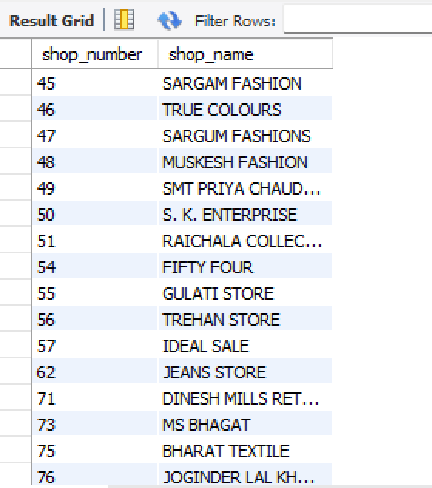

**POPULATED TABLES**

**Visitor**

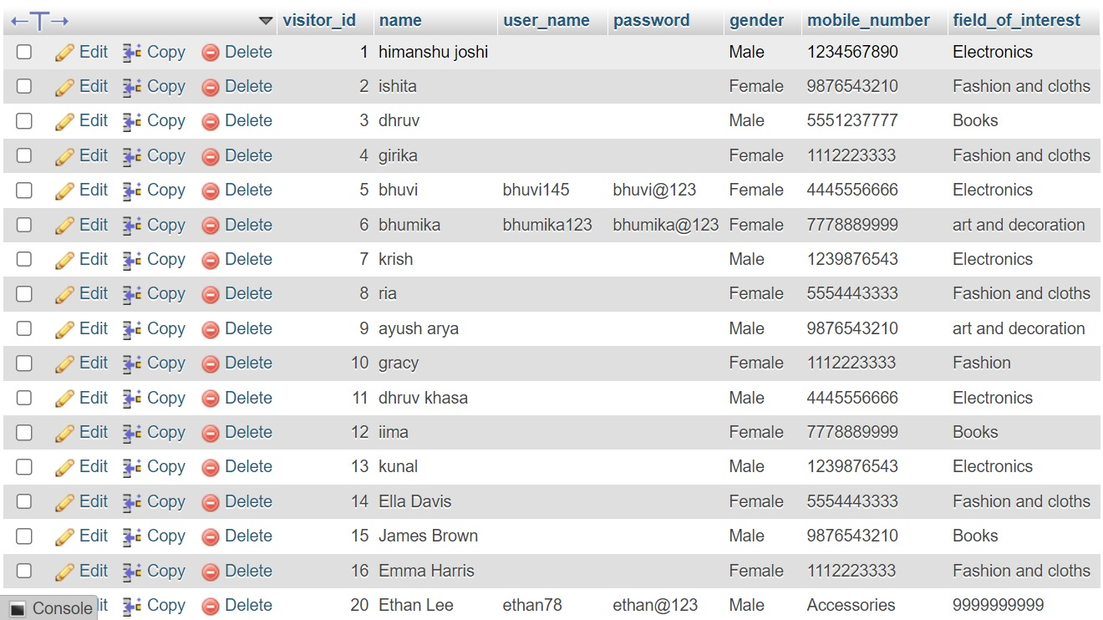

**Variety**

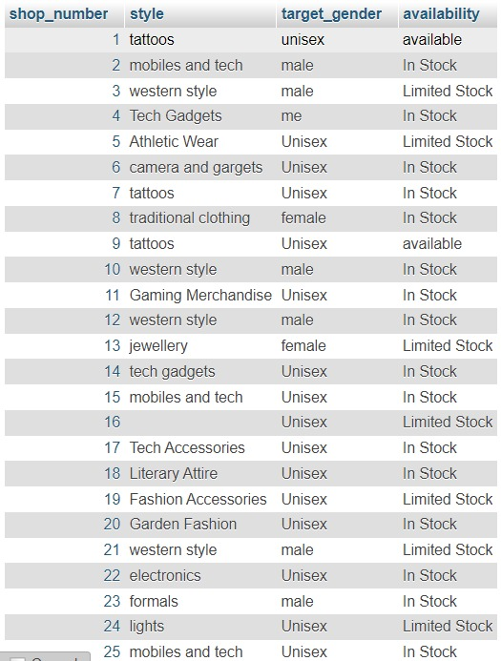

**Staff:**

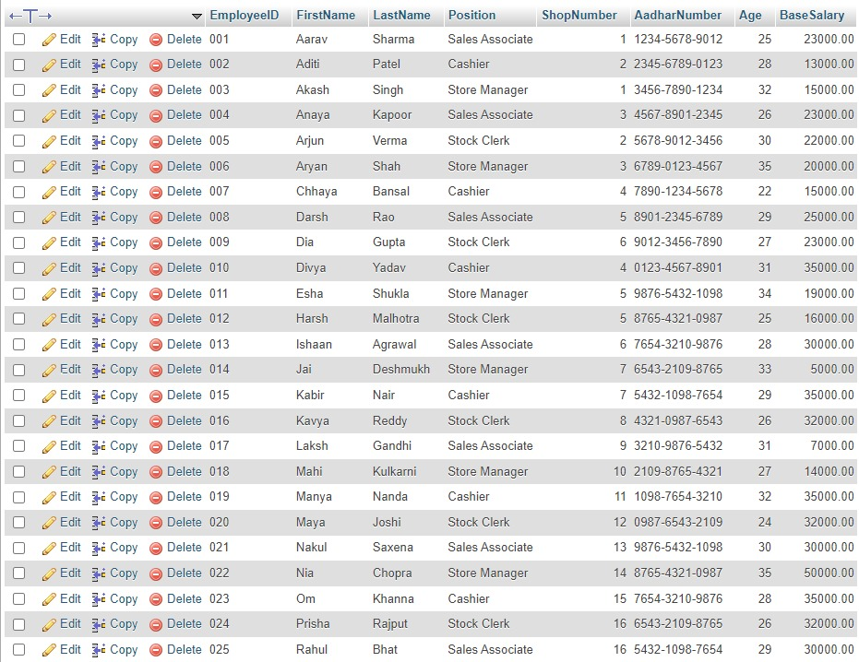

**Shops:**

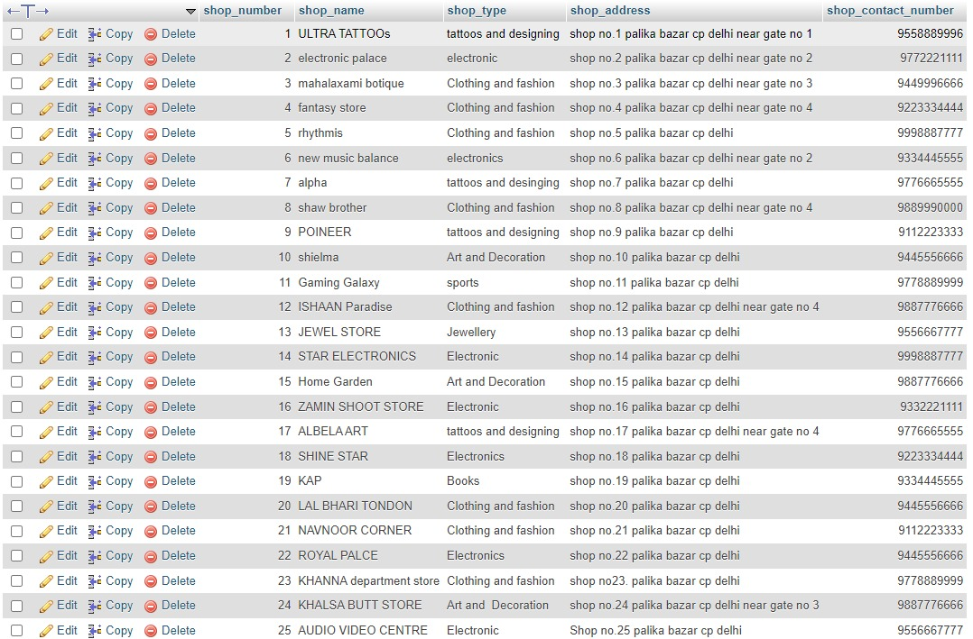

**Accessibilty:**

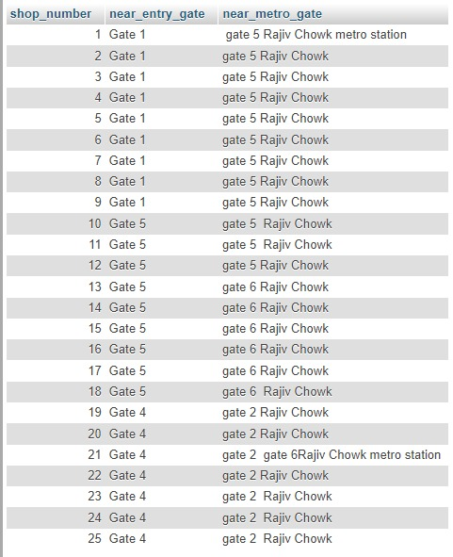

**DB Connectivity**

The database has been connected to the frontend user interface using PHP as the scripting language. The code for establishing the connection is as follows:

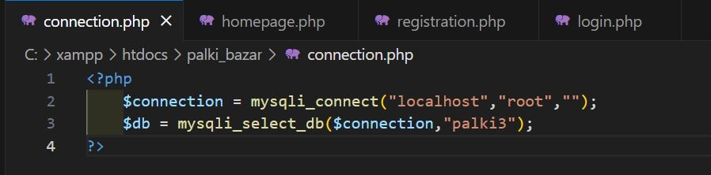

The above code serves to establish the connection between the backend (database) and frontend (user interface).

The PHP codes corresponding to each functionality being implemented are mentioned along with the respective functionality in the following pages.

**Functionalities**

Following are the functionalities implemented in our project :

**Registration:**

It’s a sign up for a new user with following details:

* Name-Type their name
* Username-Make your own username with mix of all characters
* Gender-Select your gender
* Field of interest-Select your field of interest from following options
* Contact no
* Password: Create your own password for essential credentials

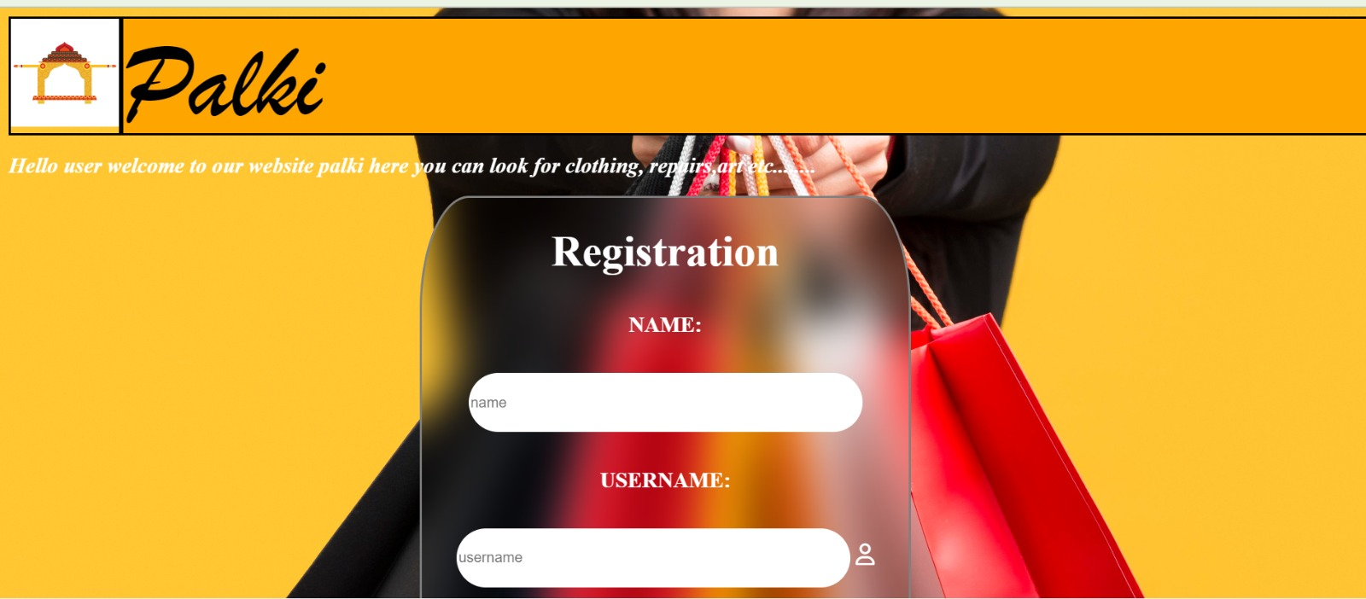

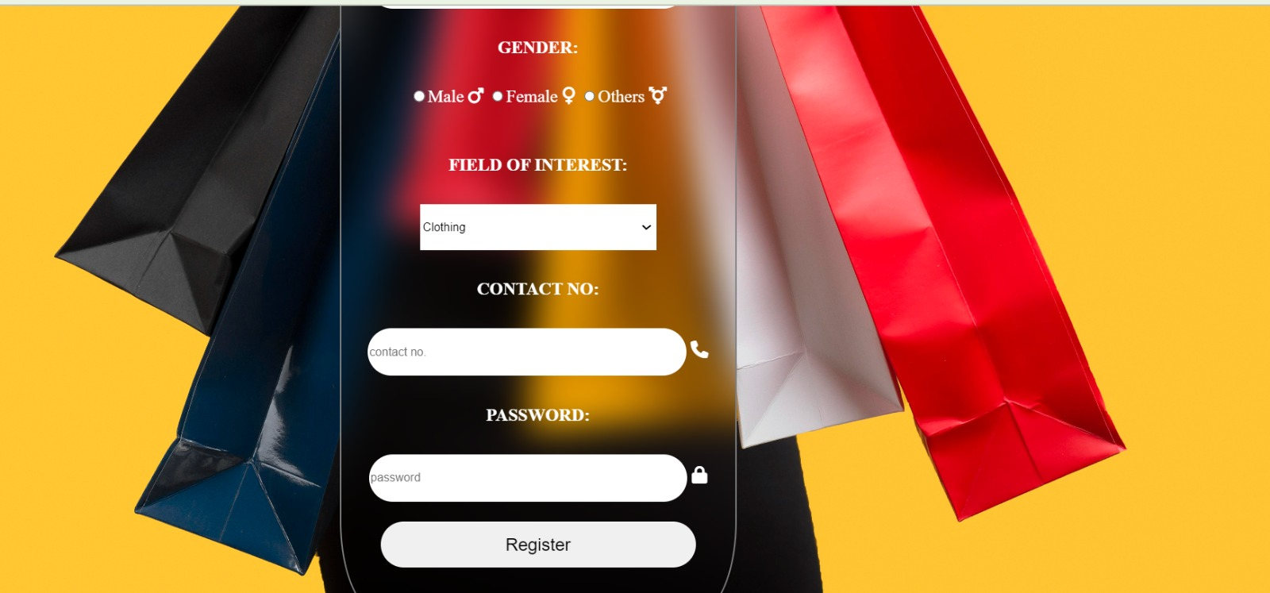

**Login:**

A login system for visitors to access our website if they have not login they can click for register here too.

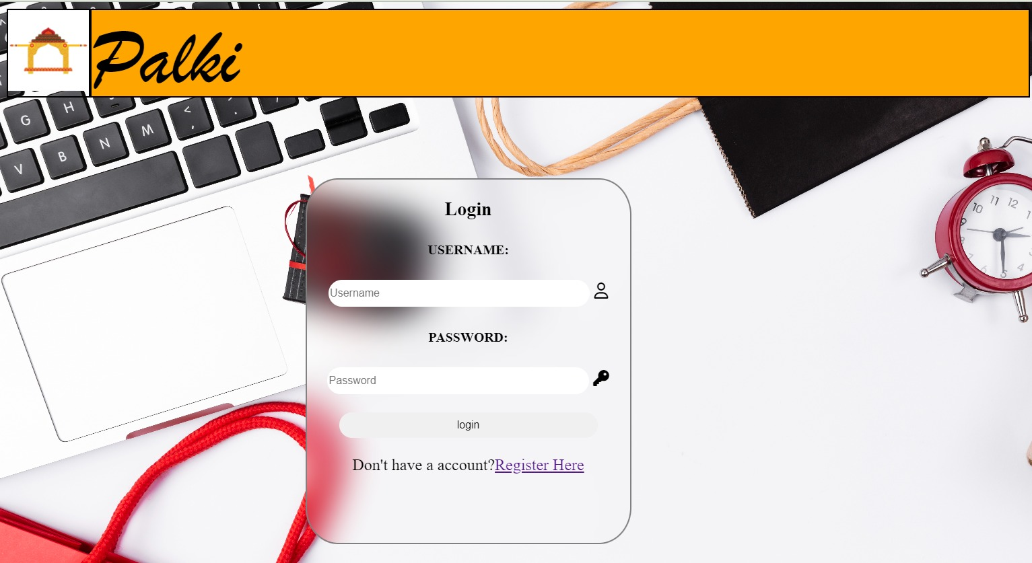

**Homepage:**

Our Homepage for Palki from here you can redirect yourself to login,registration,and our Find what you care for option and can even look for map of Connaught place,and Google map of Palika Bazaar by clicking on the location icon

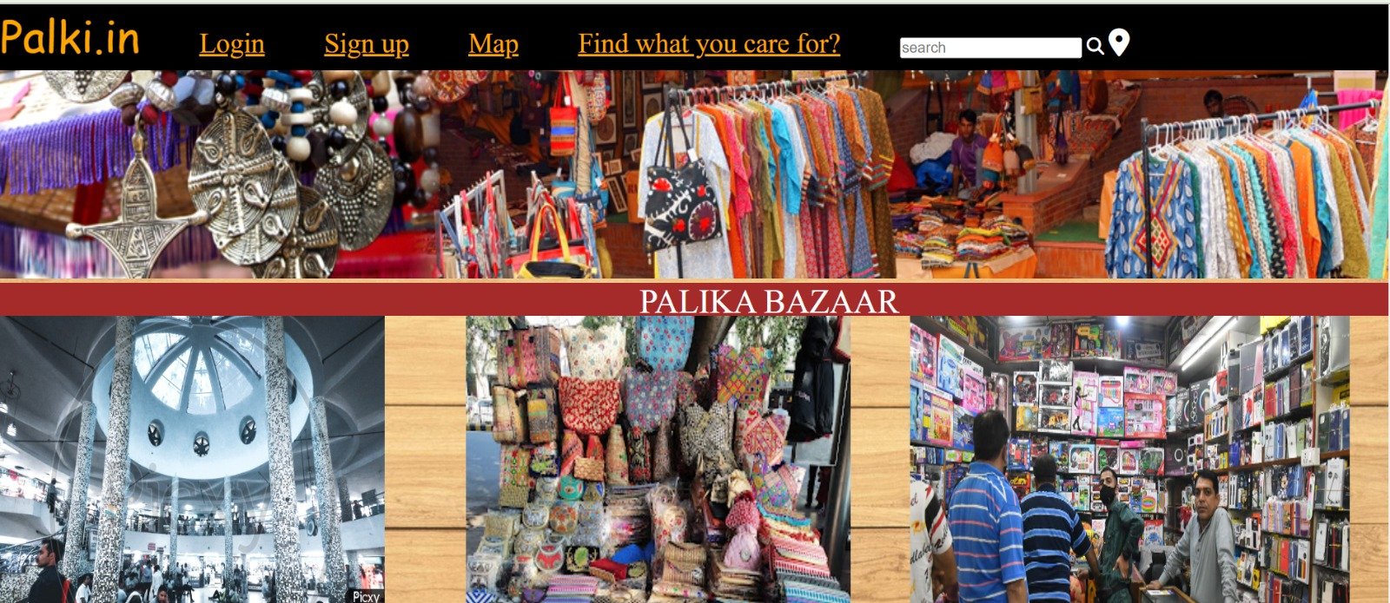

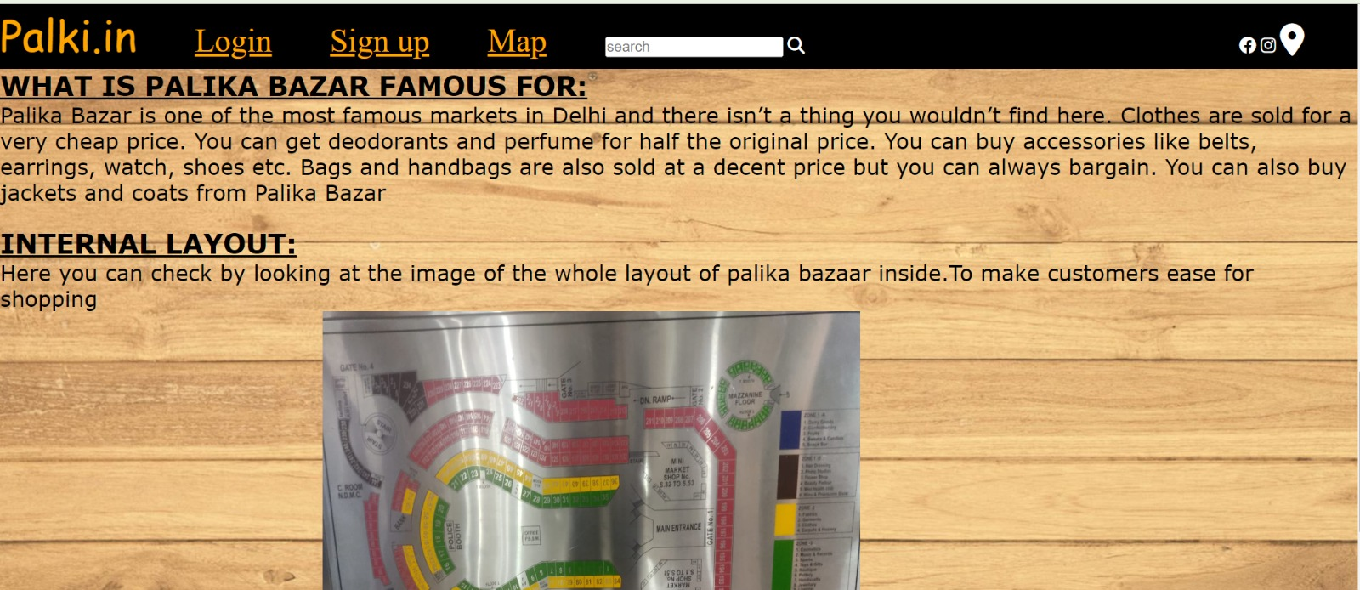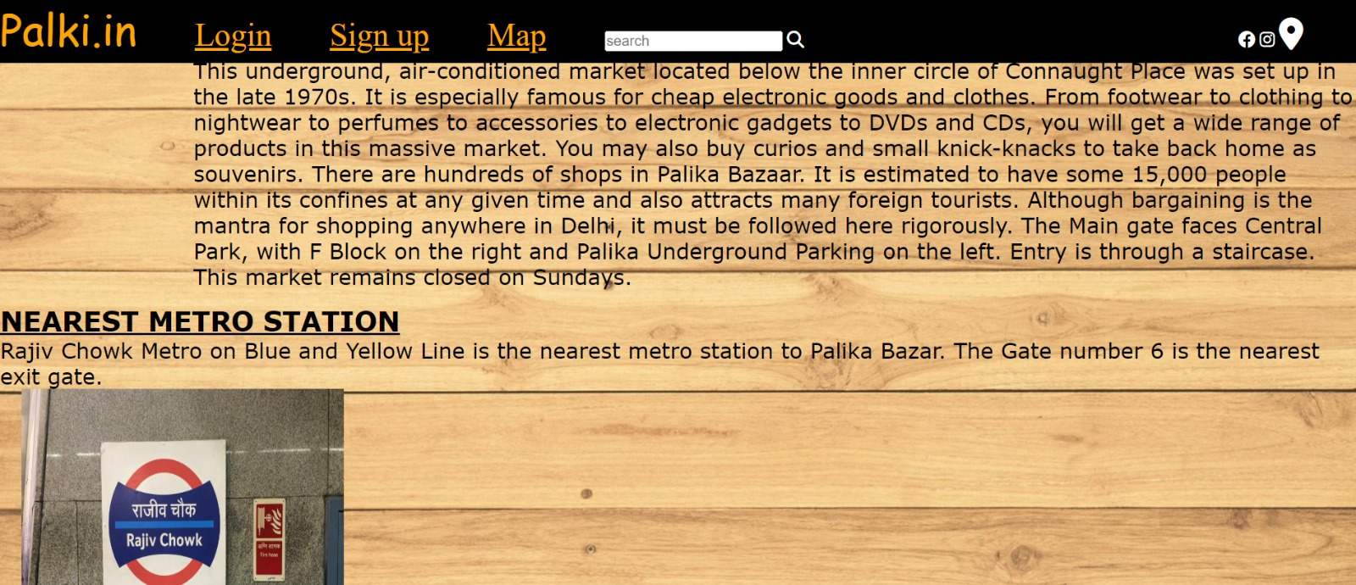

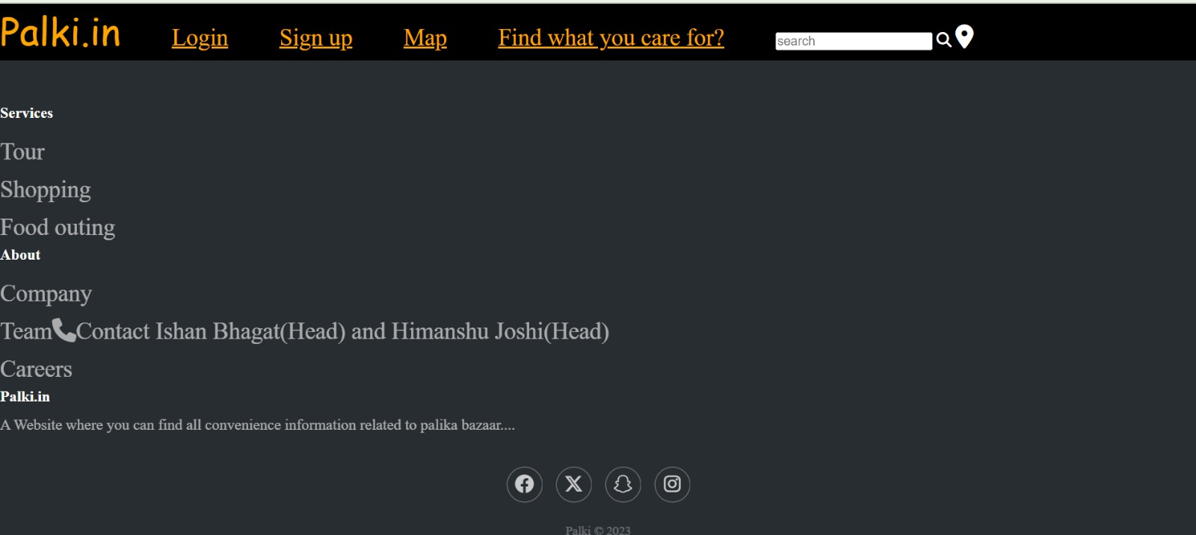

**Maps:**

**Map of both Connaught place a popular destination in Delhi along with google map of Palika Bazaar**

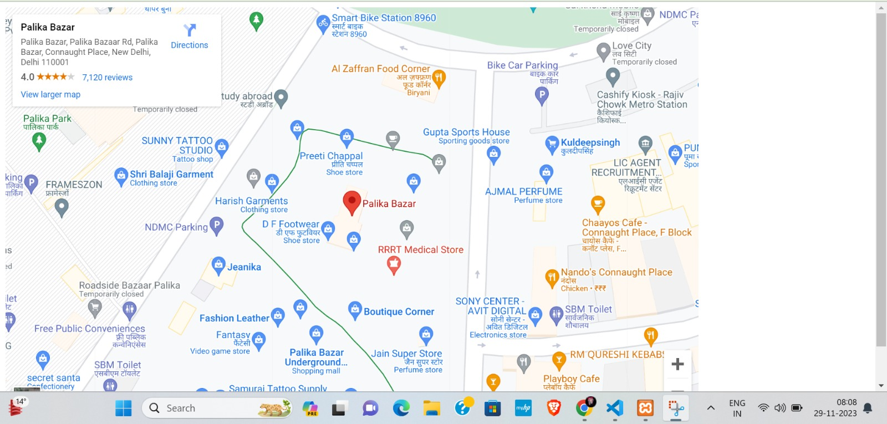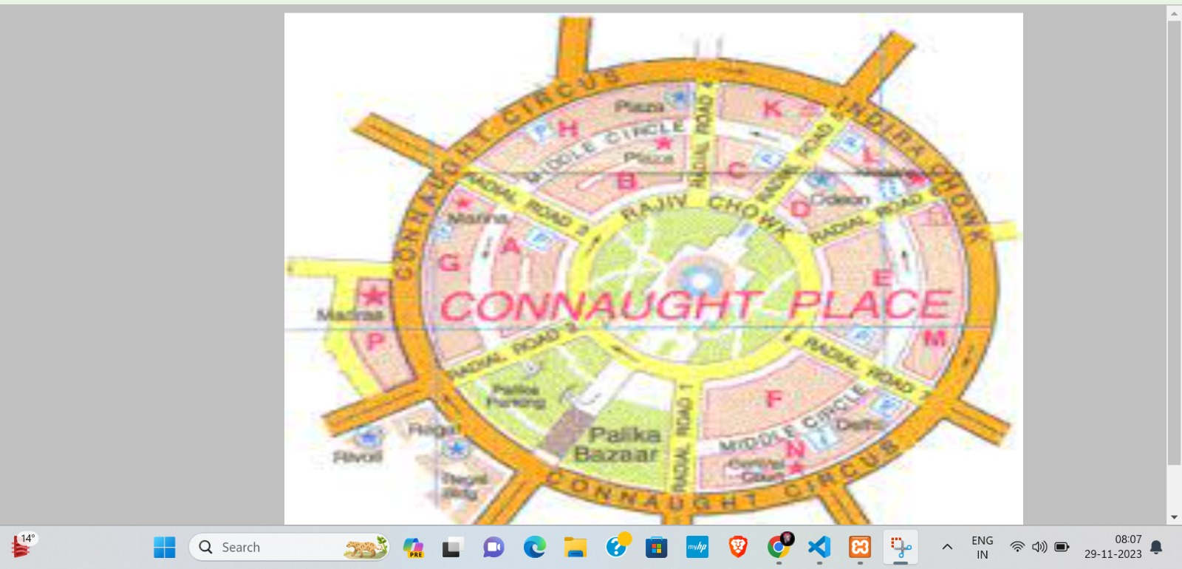

**Find what you care for?**

Our special feature of this project

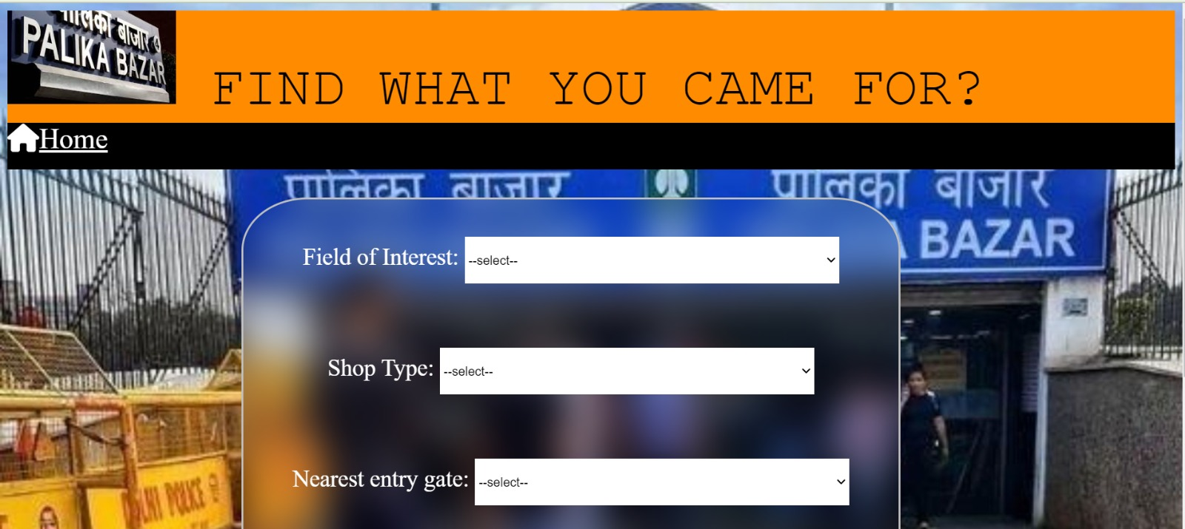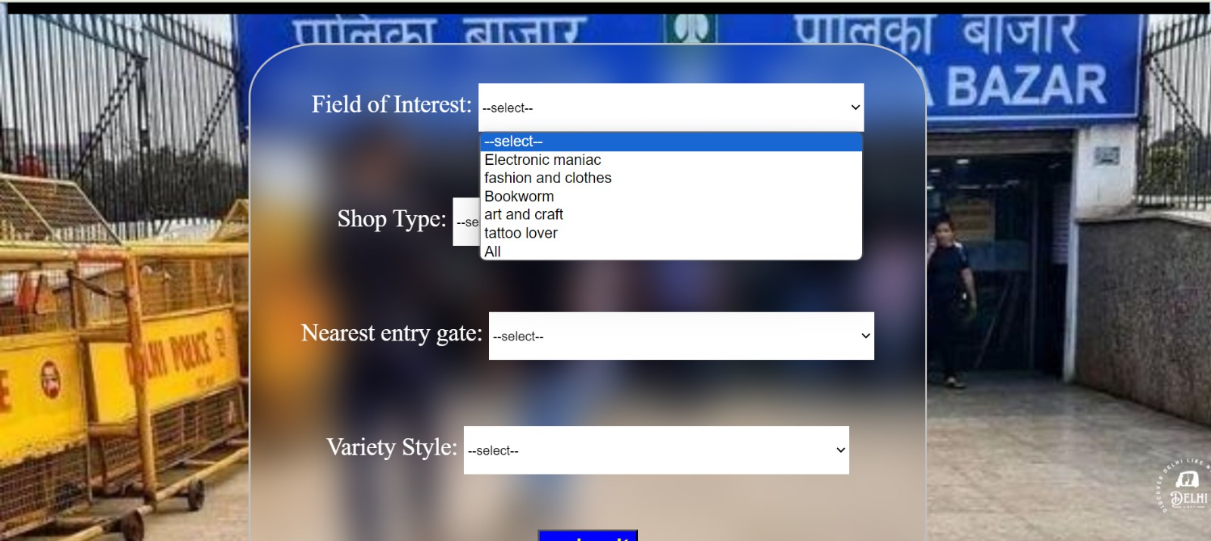It is basically a web page where visitors can filter out various shops,varieties,and the items that they are looking for…

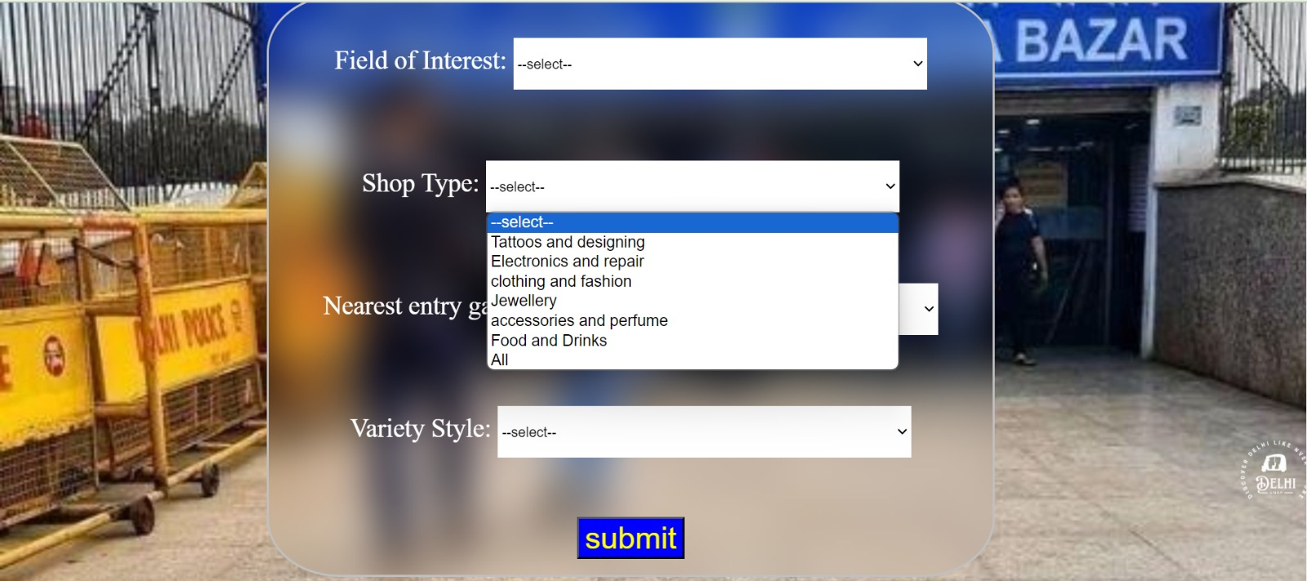

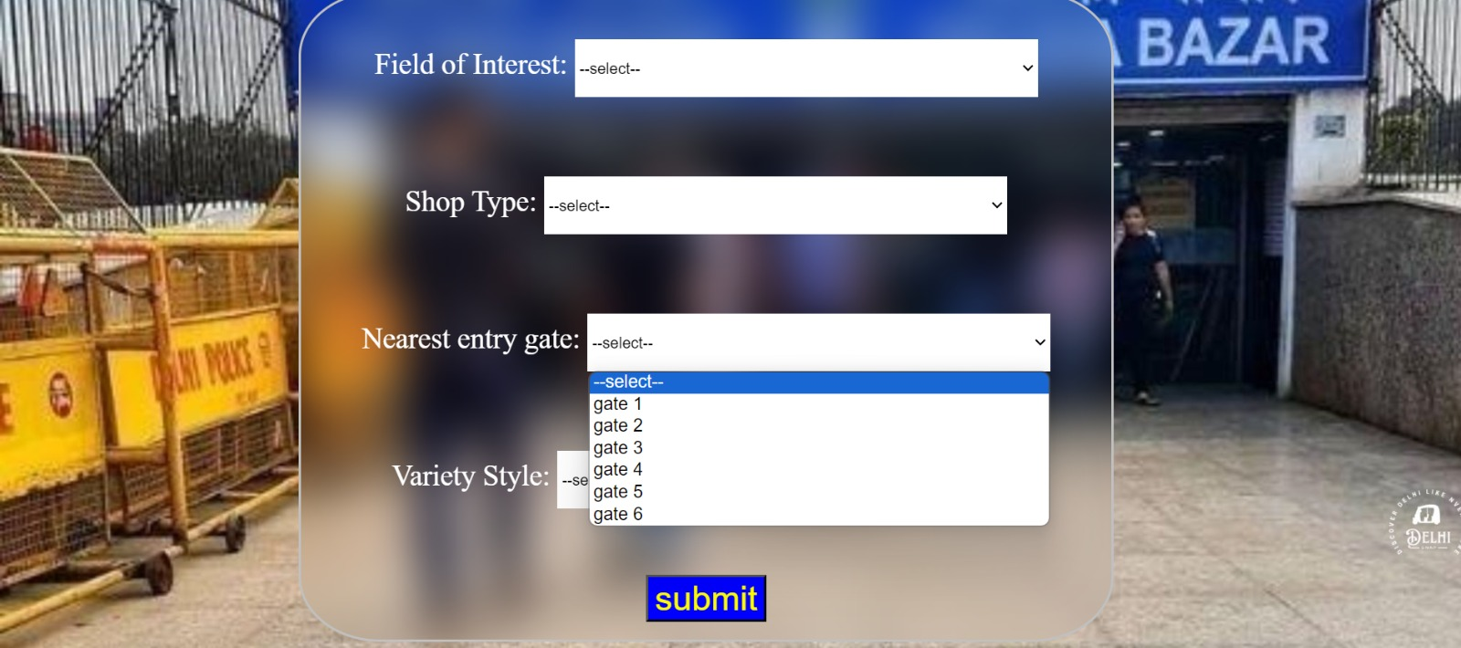

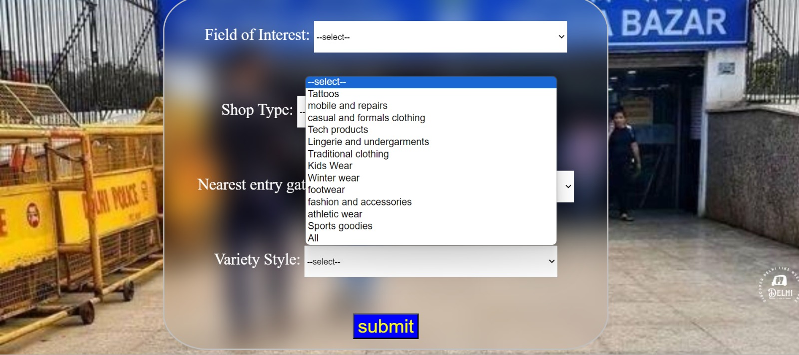

**The output we get after applying filter**

**Result 1**

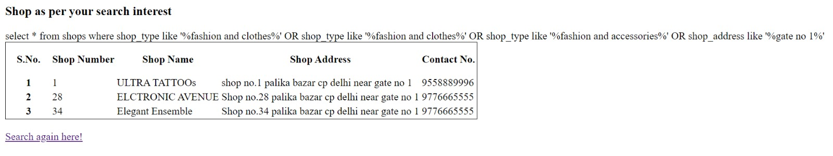

**Result 2**

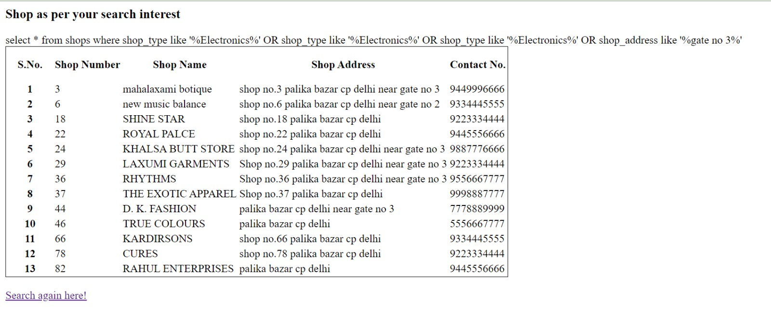

**BIBLIOGRAPHY**

* Database System Concepts
  + Author name: Korth, S. Sudarshan, Silberschatz
  + Publisher: McGrow
  + Edition: 6th edition
* Fundamentals of Database Systems -
  + Author Name: Elmasri, Navathe
  + Publisher: Pearson
  + Edition: 7th edition
* [https://stackoverflow.com/questions/43781677/my](https://stackoverflow.com/questions/43781677/mysql-database-and-jdbc/43782065#43782065) [sql-database-and-jdbc/43782065#43782065](https://stackoverflow.com/questions/43781677/mysql-database-and-jdbc/43782065#43782065)
* <https://youtu.be/YDH7f9dTXAs>
* <https://www.w3schools.com/sql/default.asp>

##### ADVANCED QUERIES

|  |  |  |
| --- | --- | --- |
| **Query** | **Syntax** | **Function** |
| **SELECT,**  **Between** | SELECT EmployeeID, FirstName, LastName, Position, Age  FROM staff  WHERE Age BETWEEN 25 AND 30; | Information of the employee and their position who have age in between 25-30 |
| **SELECT, JOIN** | SELECT s.*, v.style, v.target_gender, v.availability  FROM shops s  JOIN variety v ON s.shop_number = v.shop_number  WHERE v.style = 'bra and undergarments'; | Selecting shops that sells bra and undergarments using nested query |
| **SELECT,**  **Inner join**  **Wher** | SELECT visitor.name, visitor.field_of_interest, shops.shop_name  FROM visitor  INNER JOIN variety ON visitor.field_of_interest = variety.style  INNER JOIN shops ON variety.shop_number = shops.shop_number; | This query retrieves information about visitors who have shown interest in various fields  and the corresponding shops they are interested in. |

|  |  |  |
| --- | --- | --- |
| **SELECT,**  **< avg** | SELECT  *  FROM staff  WHERE BaseSalary > (SELECT AVG(BaseSalary) FROM staff); | Retrieve the staff who have more salry than agv |
| **SELECT,**  **Order by** | SELECT *  FROM staff  ORDER BY BaseSalary ASC; | Oreder by staff according to your basesalary |
| **SELECT, having , GROUP BY** | SELECT ShopNumber, COUNT(*) AS EmployeeCount  FROM staff  GROUP BY ShopNumber  HAVING EmployeeCount > 2; | Count number of shops that have more than one employee |
| **SELECT, MAX, MIN, AVG,** | SELECT  Position,  AVG(Age) AS AverageAge  FROM staff  GROUP BY Position; | Average age of employee by position |

|  |  |  |
| --- | --- | --- |
| **Nested query** | SELECT shop_number , shop_name , shop_type  FROM shops  WHERE shop_number in (SELECT shop_number FROM accessibility WHERE near_entry_gate = 'Gate 1'); | .to get information of all shop that are near gate 1 |
| **Subquery with ‘IN’**  **CLAUSE** | SELECT shop_name  FROM shops  WHERE shop_number IN (SELECT shop_number FROM variety WHERE style = 'Western casual style' ); | retrieves the names of shops that have at least one visitor interested in the 'Western casual style' field of interest |